Directorate for Engineering Advisory Committee Members

Francine Berman

Dr. Francine Berman is a professor in the UC San Diego Department of Computer Science and Engineering, a Fellow of the Association for Computing Machinery, and the first holder of the High-Performance Computing Endowed Chair in the Jacobs' School of Engineering at UC San Diego. Dr. Berman is a pioneer in grid computing and an international leader in the development of cyberinfrastructure. She has worked extensively in the areas of adaptive middleware, parallel programming environments, scheduling, and high performance computing. Since 2001, Dr. Berman has served as Director of the San Diego Supercomputer Center (SDSC) where she leads a staff of more than 400 interdisciplinary scientists, engineers, and technologists in the innovation and provision of national-scale cyberinfrastructure. Dr. Berman is one of the two founding Principal Investigators of the National Science Foundation's TeraGrid project, and also directed the National Partnership for Advanced Computational Infrastructure, a consortium of 41 research groups, institutions, and university partners with the goal of building national infrastructure to support research and education in science and engineering.
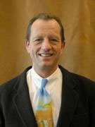
John C. Crittenden
John Crittenden holds the Richard Snell Presidential Chair of Civil and Environmental Engineering in the Department of Civil and Environmental Engineering at Arizona State University. He is also Director of the Sustainable Technologies Program at Arizona State and Associate Editor of Environmental Science and Technology. Dr. Crittenden has been involved in 55 research projects totaling more than 22 million dollars that resulted in over 100 publications and two patents. Some of the more notable projects include the 1) director of the EPA sponspored Center for Clean Industry and Treatment Technologies; 2) development of software and models that are widely used in the water industry and can be used to design adsorption, air stripping and oxidation processes; and 3) an evaluation of the water treatment system for the space station Freedom. Dr. Crittenden and his students have received 16 national awards including the American Society of Civil Engineering Huber Research Prize, two American Water Works Association best paper awards, two Water Environment Federation best paper awards, and the ASCE Rudolph Hering medal. Dr.Crittenden is a member of the National Academy of Engineering.

Lesia Crumpton-Young
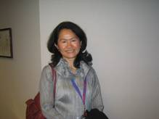
Lesia Crumpton-Young serves as professor and Department Chair of the Industrial Engineering and Management Systems Department at University of Central Florida. She is also Co-Director of the NSF I/UCRC in E-Design: IT Enabled Design and Realization of Engineered Products and Systems and an active researcher in the area of modeling Human Systems under Dynamic conditions. She previously held the positions of associate dean of Engineering and developer and director of the Ergonomics/Human Factors Program and Experimentation Laboratory at Mississippi State University (MSU). She has served as Principal Investigator on numerous research projects and published more than 150 scholarly publications. Her research has been externally supported by NSF, ONR, NASA, and DOE. She has also worked on many industrial research projects with companies such as UPS, IBM, Caterpillar, Intel, Garan Manufacturing, Southwest Airlines, and Lockheed Martin. She has received numerous awards including the 1999 Janice A. Lumpkin educator of the Year Golden Torch Award from the National Society of Black Engineers. She is a senior member of the Institute of Industrial Engineers, the Human Factors and Ergonomics Society, and a member of Alpha Pi Mu (Industrial Engineering Honor Society).

Wesley L. Harris
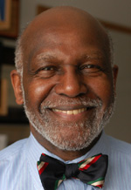
Wesley L. Harris is Head of the MIT Department of Aeronautics and Astronautics where he is the Charles Stark Draper Professor of Aeronautics. He also directs MIT's Lean Sustainment Initiative. Dr. Harris served as a NASA associate administrator for aeronautics, responsible for all aeronautics programs, facilities, and personnel from 1993 to1995. From 1990 to 1993, he was the vice president and chief administrative officer for the University of Tennessee Space Institute. From 1985 to 1990, he served as Dean of the School of Engineering and Professor of Mechanical Engineering at the University of Connecticut. From 1972 to 1985, he held faculty and administrative positions at MIT including professor of aeronautics and astronautics. His academic research is associated with unsteady aerodynamics, aeroacoustics, rarefied gasdynamics, sustainment of capital assets, and chaos in sickle cell disease, having made seminal contributions in each of these research fields. In academe, he has worked with industry and governments to design and build joint industry - government - university research and development programs, centers, and institutes and has transferred technology effectively. He is credited with more than 100 technical papers and presentations.
Marshall Jones
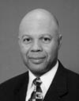
Marshall G. Jones was Manager of the General Electric Laser Technology Program from 1981 to 1985 and is presently a project leader in laser technology. He holds 37 US Patents. In 1985, Dr. Jones' research on laser/fiber optic/robot systems was voted one of the nation's top 100 innovations of the year by Science Digest Magazine. He received the 1986 Distinguished Engineering Alumni Award from the University of Massachusetts. In 1987, he was awarded the Chancellor's Medal from the University of Massachusetts. In 1990, he was elected a Senior Member of the Laser Institute of America. In 1994, Dr. Jones received the Black Engineer of the Year Award for “Outstanding Technical Contribution in Industry,” and was elected a Fellow of the American Society of Mechanical Engineers (ASME). He received the 1995 Distinguished Achievement Award for Professional and Community Service from the University of Massachusetts. In 1997, he received ASME’s Dedicated Service Award. In 1998, he received the American Welding Society’s Prof. Dr. Rene Wasserman Memorial Award. In 1999, Dr. Jones received the National Society of Black Engineers’ Pioneer of the Year Golden Torch Award. In 2000, he received the Black Engineer of the Year Award for “Outstanding Alumnus Achievement.” He was elected to the National Academy of Engineering in 2001.
Cato Laurencin

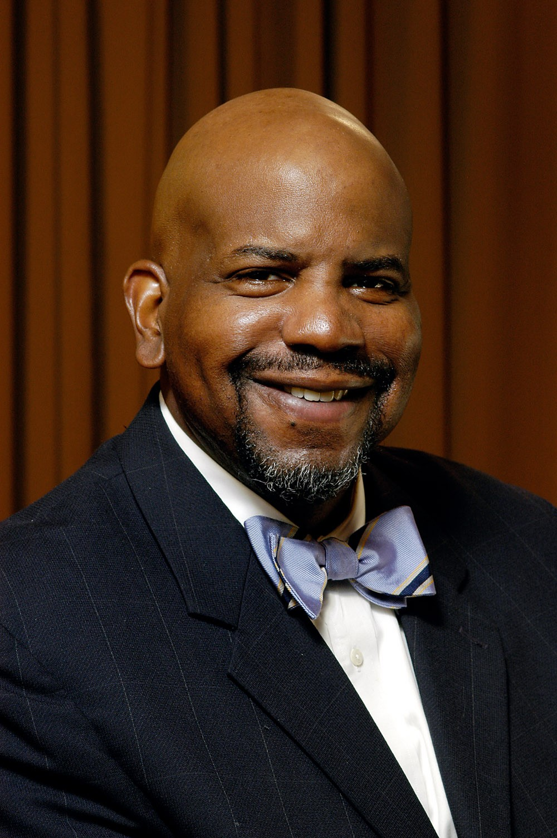
Cato T. Laurencin, M.D., Ph.D. is the Lillian T. Pratt Distinguished Professor, a University Professor, and Chair of the Department of Orthopaedic Surgery at the University of Virginia. In addition, Dr. Laurencin is Professor of Biomedical Engineering and Professor of Chemical Engineering at the University of Virginia. Board certified in orthopaedic surgery, Dr. Laurencin is a Fellow of the American College of Surgeons, a Fellow of the American Surgical Association, and a Fellow of the American Academy of Orthopaedic Surgeons. His research interests include biomaterials, tissue engineering, drug delivery and nanotechnology. Dr. Laurencin received the Presidential Faculty Fellowship Award in recognition of his research involving biodegradable polymers. He recently received the William Grimes Award for Excellence in Chemical Engineering from the American Institute of Chemical Engineers, the Leadership in Technology Award from the New Millennium Foundation, and the Clemson Award for Contributions to the Biomaterials Literature from the Society for Biomaterials. Dr. Laurencin is a Fellow of the American Institute for Medical and Biological Engineering, an International Fellow in Biomaterials Science and Engineering and a member of the Institute of Medicine of the National Academy of Sciences.

Arun Majumdar
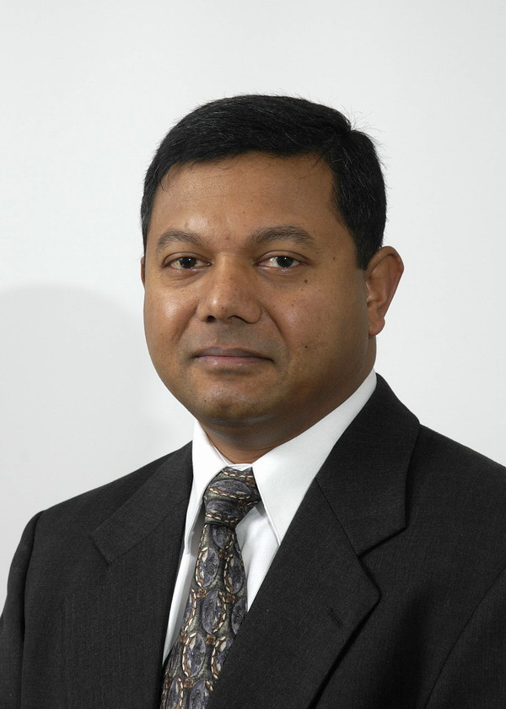
Arun Majumdar holds the Almy and Agnes Maynard Chair Professorship in the College of Engineering at the University of California, Berkeley. He also serves as the Director of the Berkeley Nanosciences and Nanoengineering Institute. Dr. Majumdar’s research interests are in the broad area of mechanics and transport in nanostructured materials, with applications in energy technology and biomedicine. He is a member of the Nanotechnology Technical Advisory Group to the President's Council of Advisors on Science and Technology and the Council of Materials Science and Engineering at the Department of Energy. He also serves on the editorial board of the International Journal of Heat and Mass Transfer, Molecular and Cellular Biomechanics, and is the editor in chief of Micro/Nanoscale Thermophysical Engineering. He served as the founding chair of the American Society of Mechanical Engineers (ASME) Nanotechnology Institute. Dr. Majumdar is the recipient of numerous awards and medals including the NSF Young Investigator Award, the Institute Silver Medal (IIT-B), the ASME Gustus Larson Memorial Award, and the Distinguished Alumni Award from IIT-B. He is a fellow of ASME and AAAS, and is a member of the US National Academy of Engineering.

Gary May, Advisory Committee Past Chair
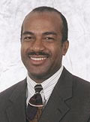
Gary S. May is the Steve W. Chaddick School Chair of the School of Electrical & Computer Engineering. In this capacity, he serves as chief academic officer and provides leadership to over 100 faculty members and 2,400 students in the School. From 2002-2005, Dr. May previously served as executive assistant to Georgia Tech President G. Wayne Clough. In 2001, he was named Motorola Foundation Professor, and was appointed associate chair for Faculty Development. Dr. May’s research is in the field of computer-aided manufacturing of integrated circuits. He has authored over 200 articles and technical presentations in the area of IC computer-aided manufacturing and was Editor-in-Chief of IEEE Transactions on Semiconductor Manufacturing (1997-2001). Dr. May is the founder of Georgia Tech’s Summer Undergraduate Research in Engineering/Science (SURE) program, a summer research program designed to attract talented minority students into graduate school. He also is the founder and director of Facilitating Academic Careers in Engineering and Science program (FACES), a program designed to encourage minority engagement in engineering and science careers. He is a member of the National Advisory Board of the National Society of Black Engineers (NSBE).

Richard Miller, Advisory Committee Chair

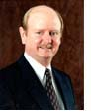
Richard Miller is the founding President and a Professor of Mechanical Engineering at Franklin W. Olin College of Engineering. Before joining Olin College, he was Dean of the College of Engineering at the University of Iowa. He also served on the engineering faculties at the University of Southern California (where he held the position of Associate Dean for Academic Affairs) and the University of California, Santa Barbara. With research interests in earthquake engineering and aerospace structural design, he has served as a consultant to many aerospace companies and directed research programs funded by NSF, NASA, and industry. Dr. Miller has published extensively in the field of applied mechanics, and has won five awards for teaching excellence. He is a member of the Boards of Trustees of Babson College and of Olin College, the Board of Directors of The Stanley Group, the Council on Competitiveness, and serves on several advisory boards for non-profit organizations and universities. He is also a member of AIAA, ASCE, ASEE, ASME, Tau Beta Pi, Phi Kappa Phi, and Sigma Xi.

Margaret Murnane
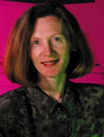
Margaret Murnane is a Fellow at the Joint Institute for Laboratory Astrophysics and a member of the Department of Electrical and Computer Engineering and the Department of Physics at the University of Colorado. She received her B.S and M.S. degrees from University College Cork, Ireland, and her Ph.D. degree in physics from the University of California at Berkeley in 1989, and joined the faculty of physics at Washington State University in 1990. In 1996, Dr. Murnane moved to the University of Michigan, and in 1999 she moved to the University of Colorado. She runs a joint research group and a small laser company with her husband, Dr. Henry Kapteyn. Dr. Murnane's research interests have been in ultrafast optical and x-ray science. She is a Fellow of the American Physical Society and the Optical Society of America. She was recognized as the Maria Goeppert-Mayer Award of the American Physical Society and a John D. and Catherine T. MacArthur Fellow. She was elected to the National Academy of Sciences and is a Fellow of the American Academy of Arts and Sciences.

Alan Needleman
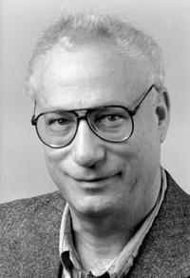
Alan Needleman is a professor in the Mechanics and Solids Structures Group in the Division of Engineering at Brown University. His main research interests are in the computational modeling of deformation and fracture processes in structural materials, in particular metals. Ongoing research projects involve studies of ductile fracture and ductile-brittle transitions; crack growth in heterogeneous microstructures with particular emphasis on the role of interfaces; nonlocal and discrete dislocation plasticity; fatigue crack growth; and fast fracture in brittle solids. Dr. Needleman is a member of the National Academy of Engineering, a fellow of the American Society of Mechanical Engineers, a fellow of the American Academy of Mechanics, an honorary member of MECAMAT (Groupe Français de Mecanique des Matériaux) and a foreign member of the Danish Center for Applied Mathematics and Mechanics. He has been recognized by ISI (Science Citation Index) as a highly cited author, both in Engineering and in Materials Science. In 1994, his work on 3D modeling of metallic fracture was a finalist in the Science Category for the Computerworld-Smithsonian Award.

Cherri Pancake


Cherri M. Pancake is Professor of Electrical Engineering and Computer Science and Intel Faculty Fellow at Oregon State University. Her first career was in ethnography. Dr. Pancake was among the first worldwide to apply ethnographic techniques to identify software usability problems – an approach which is now mainstream – and she conducted much of the seminal work identifying how the needs of scientists differ from the needs of the computer science and business communities. She is Director of the Northwest Alliance for Computational Science and Engineering (NACSE), an interdisciplinary research center often cited as the national leader in usability for science and engineering applications. The methods she developed for applying user-centered design to improve user interfaces are reflected in software products from Hewlett Packard, Convex, Intel, IBM, and Tektronix. Most recently, Dr. Pancake has focused on how "virtual collaborations" differ from situations where colleagues have the opportunity to meet and work together physically. She develops processes and software tools to make remote collaboration fit naturally into the normal patterns of scientific research and practice. Dr. Pancake is a Fellow of the Association for Computing Machinery and the Institute of Electrical and Electronics Engineers.

Winfred Phillips
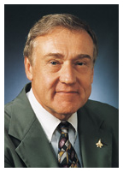
Winfeld Phillips has been Vice President for Research and Don and Ruth Eckis Professor of Biomedical Engineering at the University of Florida since 1999. Before that he served as Dean of the Graduate School for five years and Dean of the College of Engineering for eleven years. He has also held positions at Purdue University as a professor of mechanical engineering and head of the School of Mechanical Engineering and as Associate Dean for Research in the College of Engineering, Acting Chairman of the Intercollegiate Biomedical Engineering Program and professor of aerospace engineering at Penn State University. He is a fellow and past president of the American Society of Mechanical Engineers, a fellow and past president of the Accreditation Board for Engineering and Technology, a fellow of the American Association for the Advancement of Science, chair of the Board of the American Association of Engineering Societies, a fellow and past president of the American Institute for Medical and Biological Engineering, a fellow and past president of the American Society for Engineering Education, a fellow of the New York Academy of Sciences, a fellow of the American Astronautical Society, a fellow of the American Institute for Aeronautics and Astronautics, a fellow of the Biomedical Engineering Society, a fellow of the Royal Society of the Arts, past president of the American Society for Artificial Internal Organs, past chair of the Board of the Southeastern Consortium for Minorities in Engineering, and a member of the Board of Enterprise Florida, Inc.
Jacquelyn Sullivan

Jacquelyn Sullivan is founding Co-Director and Director of K-12 Engineering for the Integrated Teaching and Learning Program at the University of Colorado at Boulder, focused on integrating hands-on
engineering throughout the K-16 learning experience. Dr. Sullivan had 13 years of engineering and leadership experience in industry prior to joining CU's College of Engineering in 1990. At CU, she has initiated an extensive K-12 engineering program for teachers and under-served youth. She currently leads a multi-institutional initiative to create an online, searchable, standards-based, digital library collection of
K-12 engineering curricula, as well as Department of Education and NSF-funded projects that promote in-classroom K-12 engineering instruction. Dr. Sullivan is a founding board member for the new
Denver School of Science and Technology, and she has long served on (and chaired) the board of directors for the Boulder Arts Academy. Dr. Sullivan received her PhD in environmental health physics and aquatic toxicology from Purdue University.

E. Jennings Taylor

Dr. Taylor received his B.A. in Chemistry from Wittenberg University in 1976 and his M.S. and Ph.D. degrees in Materials Science from the University of Virginia in 1978 and 1980, respectively. Dr. Taylor also completed a Master's program in Technology Strategy and Policy at Boston University with the M.A. degree awarded in 1991. Dr. Taylor founded Faraday Technology Inc in 1991, and serves as Chief Executive and Intellectual Property Officer. In addition to technical degrees and an expansive career in technology management prior to founding Faraday, he is a licensed Patent Agent and represents Faraday on patent matters before the USPTO. In addition, Dr. Taylor has been honored with several business and personal achievement awards during his tenure with Faraday, most recently for Outstanding Professional Achievement as a technology leader by the Affiliate Societies Council of the Engineering and Science Foundation of Dayton and as an Entrepreneur of the Year finalist by Ernst & Young. Dr. Taylor has published over 120 technical publications and holds 25 U.S. patents with additional patents pending.

Matthew Tirrell

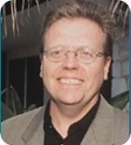
Professor Matthew Tirrell is Dean of the College of Engineering at the University of California, Santa Barbara. He received his undergraduate education in Chemical Engineering at Northwestern University and his Ph.D. in 1977 in Polymer Science from the University of Massachusetts. From 1977 to 1999, he was on the faculty of Chemical Engineering and Materials Science at the University of Minnesota, where he served as head of the department from 1995 to 1999. His research has been in polymer surface properties including adsorption, adhesion, surface treatment, friction, lubrication and biocompatibility. He has co-authored about 250 papers and one book and has supervised about 60 Ph.D. students. Professor Tirrell has been a Sloan and a Guggenheim Fellow, a recipient of the Camille and Henry Dreyfus Teacher-Scholar Award and has received the Allan P. Colburn, Charles Stine and the Professional Progress Awards from AIChE, as well as delivering its Institute Lecture in 2001. He is a member of the National Academy of Engineering, a Fellow of the American Institute of Medical and Biological Engineers, a Fellow of the American Association for the Advancement of Science, and a fellow of the American Physical Society. In 2003, he concluded more than two years of service as co-chair of the steering committee for the National Research Council report "Beyond the Molecular Frontier: Challenges for Chemistry and Chemical Engineering" published by the National Academy Press. He currently serves on the Board of Directors of the Cottage Health System.

