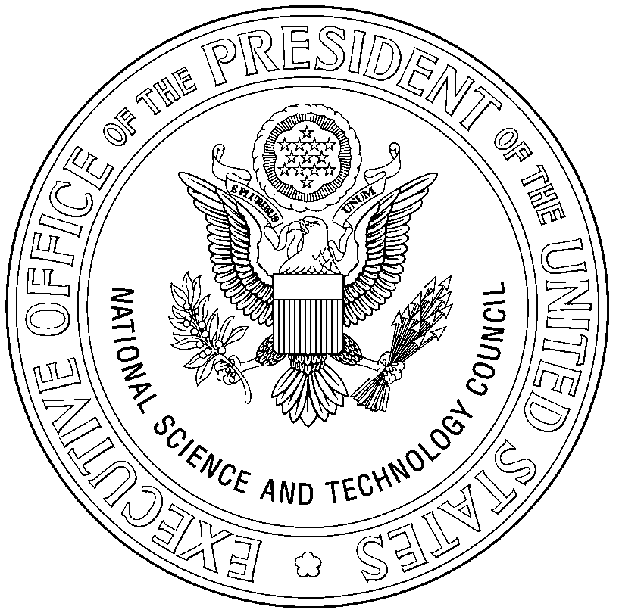

Committee on Environment & Natural Resources
U.S. Group on Earth Observations

April 12, 2005

Dear Colleague:

On behalf of the United States Group on Earth Observations (US GEO), the new CENR subcommittee established to replace the Interagency Working Group on Earth Observations (IWGEO), it is our pleasure to extend an invitation to our upcoming public engagement workshop titled, Continuing the Dialogue. This 2-day workshop will be held on Monday, May 9 and Tuesday, May 10, 2002, at the Ronald Reagan Building and International Trade Center in Washington, DC. The meeting will be focused around the nine societal benefit areas recognized in the Strategic Plan, as well as the six opportunities identified as potential areas for near-term collaboration.

We are delighted that White House Office of Science and Technology Policy Director Marburger, and NOAA Administrator Lautenbacher will open the meeting, and Health and Human Services Secretary Leavitt will provide remarks on the second day.

As you may know, the United States, through our interagency process, recently finalized its Strategic Plan for the U.S. Integrated Earth Observation System. Your participation in the early stages, as well as your comments during the public review were critical to this important document’s development. Secretary of Commerce Carlos Gutierrez presented the U.S. Plan at the third Earth Observation Summit in Brussels as the U.S. contribution to the Global Earth Observation System of Systems (GEOSS).

Now, the real work begins. We have the vision intact and are beginning to think practically about the actual integration and implementation of our own system of systems. Developing an architecture and a data management strategy are only a few of the challenges that lie ahead, and once again, should you be able to join us at this meeting, your ideas will be a valuable part of our further development of an integrated system.

We have attached an electronic copy of the prospectus and registration form for the meeting. While there is no registration fee for this meeting, we would encourage you to register as soon as possible, as space is constrained. Finally, if you haven’t already done so, we encourage you to review our Strategic Plan in its entirety. This effort has brought over a dozen federal agencies and three White House offices to the table for the past 18 months, and we’re eager to hear your thoughts.

If you have any questions about this meeting, please do not hesitate to contact the US GEO Executive Secretary, Carla Sullivan, at 202-482-5921, Carla.Sullivan@noaa.gov.

We look forward to hearing from you and to seeing you in May.

Regards,

US GEO Co-Chairs
/s/ Ghassem Asrar
/s/ Teresa Fryberger
/s/ Greg Withee

