

The Engineering Workforce: Current State, Issues, and Recommendations
Final Report to the Assistant Director of Engineering

May 2005

Engineering Task Force Members:
Charles E. Blue
Linda G. Blevins
Patrick Carriere
Gary Gabriele
Sue Kemnitzer (Group Leader)
Vittal Rao
Galip Ulsoy

Workforce Task Group Executive Summary

Charge to the Engineering Workforce Task Group (Fall 2004)
The task group on Workforce is charged to identify important trends in the engineering workforce and education systems, especially regarding diversity and globalization.

In particular, the group will:

--provide summaries of the most current statistics on engineering degrees and enrollment, and employment trends;

--highlight latest results of studies on the engineering workforce and education;

--suggest ideas for Directorate for Engineering Actions to reach the NSF goal of producing a technologically excellent and globally competitive workforce.

Approach
Assemble key statistics
Review research literature
Draw conclusions from these
Draft recommendations guided by the research
Write report
Circulate for comments
Invite suggestions and advice
Improve the report

Conclusions
- Interest in engineering is declining.
- Women and minorities are significantly underrepresented in engineering.
- Broadening participation will require changes in preparation for engineering study and in the culture of engineering schools.
- Diversifying the professoriate proceeds slowly, leaving students without role models.
- The practice of engineering is undergoing significant change but the curriculum has been slow to change.
- “Commodity” engineering will be done anywhere; the U.S. advantage will be innovation and systems management.

Summary of Recommendations
Preparation for Engineering Study
The Engineering Curriculum
Increasing Participation in Graduate Study
Diversifying the Engineering Faculty

Specific Recommendations
-Expand the Research Experiences for Teachers program.
-Establish an Advanced Placement course in Engineering.
-Support research on how people learn engineering, especially design, creativity and innovation.
-Restructure engineering education culture and pedagogy to
--Foster multidisciplinary systems level thinking among faculty and students.
--Make social impact more central to the study of engineering.
-Expand support for Research Experiences for Undergraduates, and link more closely with graduate admissions and fellowships.
-Support networks and mentoring for graduate students.
-Develop exemplary models of training faculty to improve mentoring and advising.
-Support networks for women and minority faculty.
-Develop networks of CAREER awardees, especially to share education and research integration results.
-Establish re-entry programs to attract practicing engineers to academe, especially underrepresented minorities and women.
-Implement results of institutional transformation programs, such as ADVANCE and Model Institutions for Excellence
-Provide leadership training for engineering professors and administrators to accomplish necessary changes in culture and behavior.

Table of Contents

Chapter 1. Current State of Engineering Workforce.…………….………1
Chapter 2. Diversity in Engineering Education…….…………………… 8
Chapter 3. Future Issues in Engineering Workforce….……...………….23
Chapter 4. Conclusions, Recommendations and Actions……………….32
Bibliography………………………………………………………..……40

Chapter 1

Current State of Engineering Workforce

1.1 Introduction
The ability of this nation to provide a growing economy, strong health and human services, and a secure and safe nation depends upon a vibrant, creative, and diverse engineering and science workforce. Over the last half of the 20th Century, the United States became a world super power that was strongly connected to our position as the world leader in science and technology. The major advances of the last century in communications, health, defense, infrastructure and manufacturing were enabled through an ample and well educated science and engineering workforce. This workforce was also characterized by a blend of domestic and foreign talent that allowed us to build and maintain this leadership position.
As we move into the 21st Century, we are seeing some dramatic shifts in both technology and politics that some feel may threaten this leadership position. Technology is not just changing rapidly but the pace of change is accelerating, with many new technologies promising dramatic shifts in how goods and services will be manufactured and delivered. The changes in the political landscape with the opening up of eastern Europe and China, and the emergence of Southeast Asia and India as major economic engines for their regions, has created not only a new marketplace for goods and services, but it has also created new competitors whose major strength may be in their vast resources of human capital. These new competitors have the ability to challenge our leadership position in science and technology. All of which leads to the questions,
1. Are we producing enough new engineers to meet the future demand? What is that demand?
2. Are we producing the right kind of engineers? How will new technologies and globalization impact the ability of our engineers to remain competitive?
3. What is the impact of international talent on our engineering workforce and on engineering enrollments?
The purpose of this report was to identify important trends in the engineering workforce and education systems, especially regarding diversity and globalization. In particular, the Engineering Workforce Task Group was charged with,
• Providing summaries of the most current statistics on engineering degrees and enrollment, and employment trends
• Highlighting the latest results of studies on the engineering workforce and education,
• Suggesting ideas for Directorate for Engineering Actions to reach the NSF goal of producing a technologically excellent and globally competitive workforce.
The Workforce Task Group divided this report into three main sections: (1) the current state of the engineering workforce taking a close look at the perspective of diversity and interest in engineering, (2) issues associated with diversifying the workforce and as well as preparing them for the 21st century, and (3) recommendations for the Engineering Directorate aimed at producing a diverse and effective engineering workforce for the future.
Waiting in the wings is the current study underway by the National Academy of Engineering entitled, The Engineer of 2020: A vision of engineering in the new century is underway. This study has finished its first phase and published a report that discusses many of these issues regarding the current state of engineering education. Their findings are not repeated here. The second phase of their work, which is to outline a plan for how to implement the vision of engineering captured in the report is underway and not due to be finalized until later this year. The recommendations to be developed there will have to be reconciled with those presented here.

1.2 Engineering Enrollments and Degrees Granted
Enrollments in engineering are growing substantially, according to the American Association of Engineering Societies [2]. In 2003, over 383,000 students were studying in undergraduate engineering programs, nearly matching an all time high (Figure 1.1) .This trend also carries over to degrees awarded, with bachelor’s and graduate degrees peaking in 2003. In 2003, engineering colleges awarded 70,949 bachelor’s degrees, 35,139 master’s degrees, and 5,870 doctoral degrees.
U.S. doctoral degrees reached a peak in 1997, then declined sharply with a slight increase in recent years (Figure 1.2). Figure 1.3 shows how the diversity and citizenship of graduate enrollment in engineering has been changing. There has been a dramatic decline in the traditional population of white, primarily male, students entering graduate school since 1992-93, with a corresponding dramatic increase in the number of foreign students. There has been a slow increase in the number of minority students during the same period, but these numbers are still very small in comparison to the total number of engineering students.
Fifty–three percent of people receiving engineering degrees end up working in non-engineering jobs, while approximately 24 percent of working engineers do not have bachelor’s degrees in engineering [1].
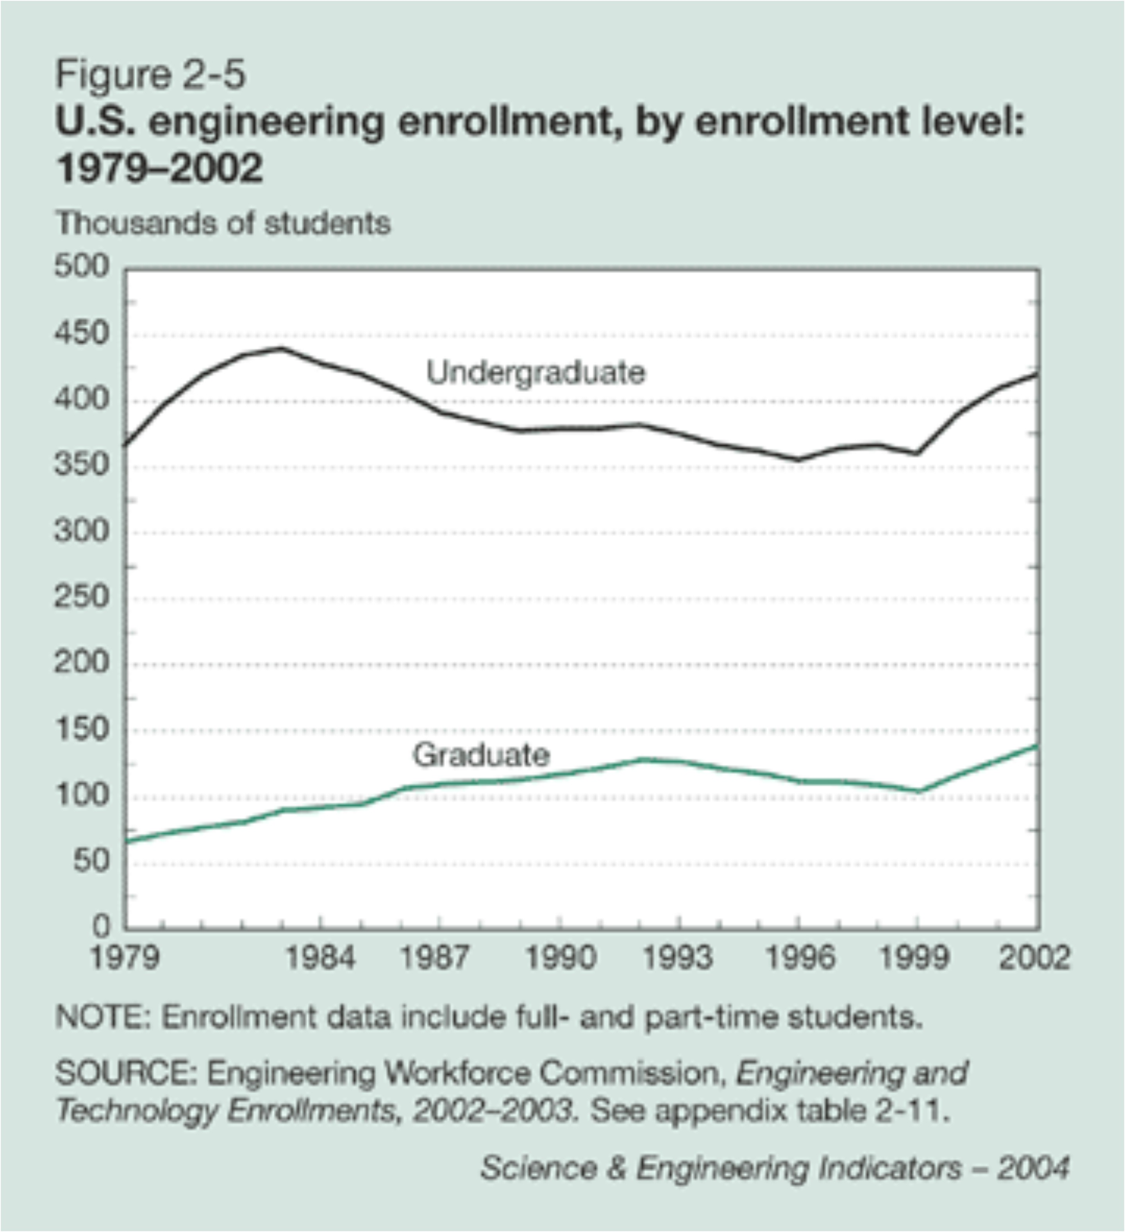
Figure 1.1: Engineering enrollments for undergraduates and graduates in thousands [1]

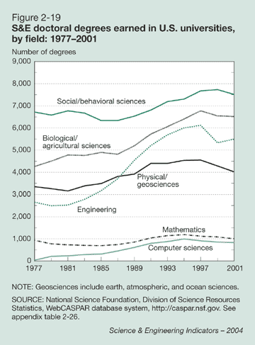
Figure 1.2: Science and engineering doctoral degrees awarded [1]

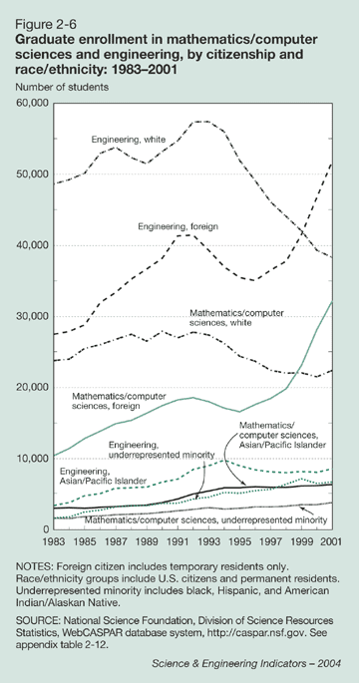
Figure 1.3: Graduate enrollment diversity and citizenship [1]

1.3 Workforce Data

1.3.1 Projected Job Growth
The Bureau of Labor Statistics (BLS) projects strong demand for engineers through 2012 [3]. Between 2002 and 2012, BLS estimates that engineering employment will grow by 7.3 percent. This is a much lower growth rate than projected for science fields, especially computer/information science occupations, which are projected to grow by 36 percent. However, some engineering subfields can expect large increased demand, such as environmental (38 percent) and biomedical (26 percent) engineering.

1.3.2 Unemployment
Unemployment rates for engineers were at all time highs in recent years. In 2003, the unemployment rate for all engineers was 4.3 percent, including 7.0 percent for computer hardware engineers, 6.2 percent for electrical and electronic engineers, 5.2 percent for computer software engineers and 3.3 percent for mechanical engineers. The unemployment rate for all workers was 5.6 percent in 2003, thus marking the first time in which the unemployment rate for some engineers exceeded that of the rate for all workers.

1.3.3 Salaries
In 2004-2005, bachelor’s degree graduates see modest gains in salary offers. Among the engineering disciplines, civil engineering graduates posted a 5.1 percent increase in their average starting salary, bringing it to $43,159. (In comparison, last year their average offer fell 1.2 percent.) Chemical engineering graduates saw a 2.1 percent increase, raising their average starting salary to $53,659. Electrical engineering graduates also posted an increase; their average offer rose 2.4 percent to $51,113. [4]. Curiously, salaries of experienced engineers have been rising despite the economic conditions. The median salary for all engineers working in industry in 2002 was $73,550, up 5.5 percent from 2000. Faculty salaries continued to increase for the academic year 2002-2003, but only at about the rate of inflation. Computer and information science faculty replaced engineering faculty at the top of the salary scale at an average of $88,502. Engineers were not far behind at $88,127. [5]

1.3.4 Visa Issues
Much has been written recently about the volume of H-1b Visas as an indicator of demand or supply of engineers. The H-1b Visa program allows foreign individuals to work in occupations requiring at least a bachelor’s degree (or to work as a fashion model). The number of visas issued each year fluctuates drastically due to changes in the Congressional cap on the number of visas. For example, in 1999 fewer than 4,000 engineers received such visas. The number then jumped to about 15,000 in 2001. Several other types of visas are also available for foreign engineers to enter the U.S. workforce, such as the intracompany transfer visas (L-1) and NATF (TN-1). Therefore it is difficult to use the H-1b Visa statistics as a measure of demand for engineers.

Chapter 2

Diversity in Engineering Education
Figure 2.1 shows that women earned 20 percent of bachelor’s degrees, 22 percent of master’s degrees, and 17 percent of doctoral degrees in engineering in 2003. Although, as shown in Figure 2.2, these percentages have increased over the past several years, they are still significantly less than the 51 percent of women in the United States population [9]. There is a slight increase in the proportion of women earning master’s degrees relative to those earning bachelor’s degrees, while there is a decrease in the proportion of women earning doctorates relative to those earning master’s degrees. Similar data for mechanical, electrical, civil, chemical, and industrial engineering disciplines (which together represent 55 percent of all engineering graduates) are depicted in Figure 2.3. Mechanical engineering graduated the lowest proportion of women (13 percent) within these disciplines, while chemical engineering graduated the highest proportion (35 percent). The proportions of women earning doctorates in the traditional fields depicted in Figure 2.3 were lower than those of women earning bachelor’s degrees.

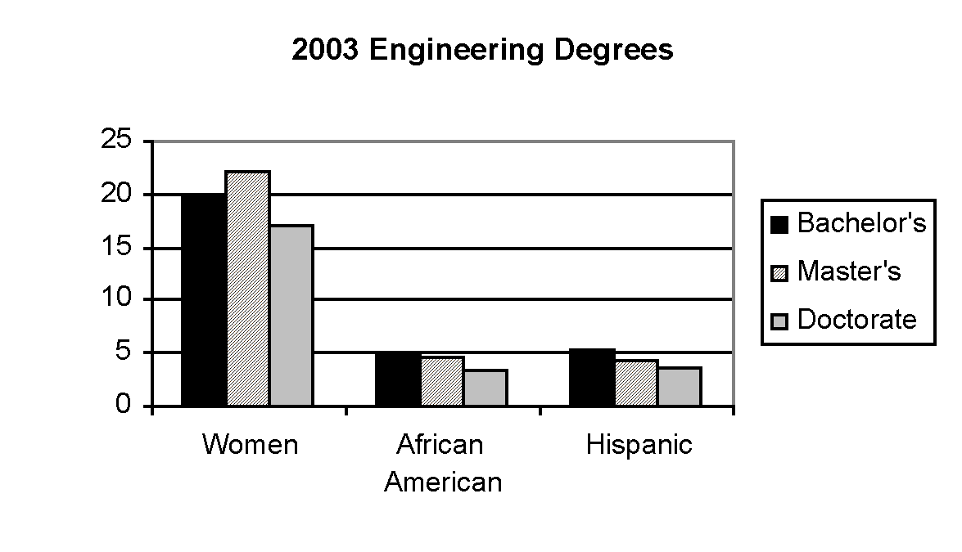
Figure 2.1: Percentage engineering degrees earned by women, African Americans, and Hispanics in 2003 [44]

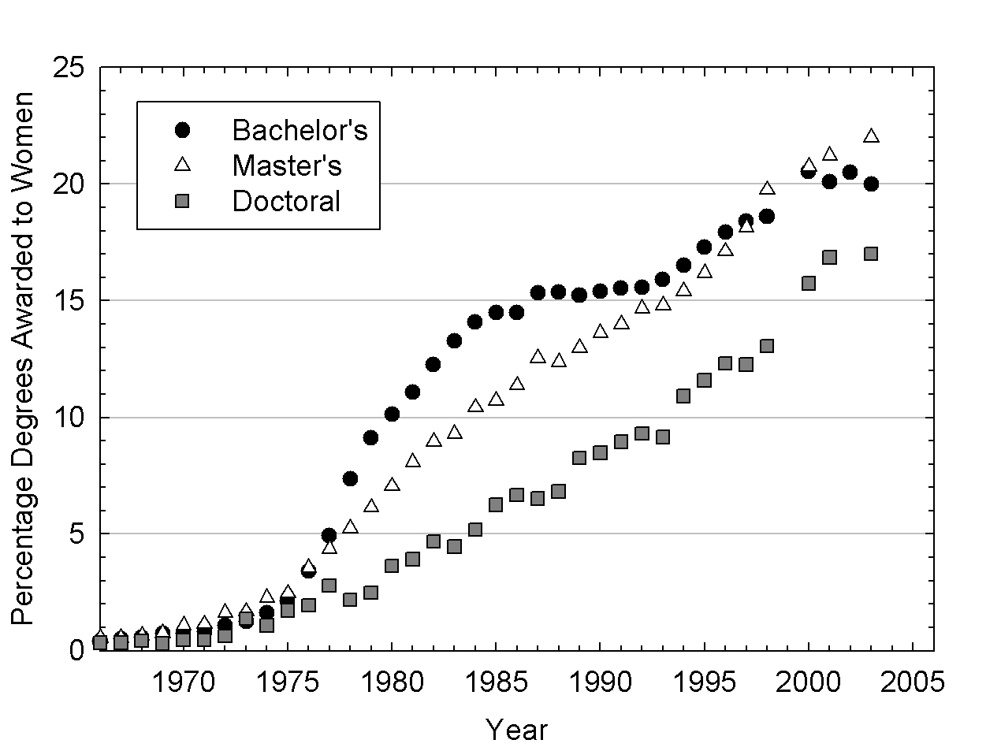
Figure 2.2: Percentage engineering degrees earned by women since 1966. [44 and 45]
Figure 2.4 shows that this was also the case for the two most rapidly growing engineering disciplines, biomedical and environmental engineering (which graduate 3 percent of engineers), although the proportions of women graduating in these fields at all levels was much higher (35-45 percent bachelor’s/master’s and 30 percent of doctorates) than those for engineering as a whole (Figure 2.2). Still, the proportion of women earning degrees in these two rapidly growing disciplines is lower than their 51 percent representation in the general population [9]. Thus, more women who are prepared to do so forego the chance to earn an engineering doctorate than men. This is sometimes referred to as the "leaky pipeline." Women exit the pipeline earlier than men.

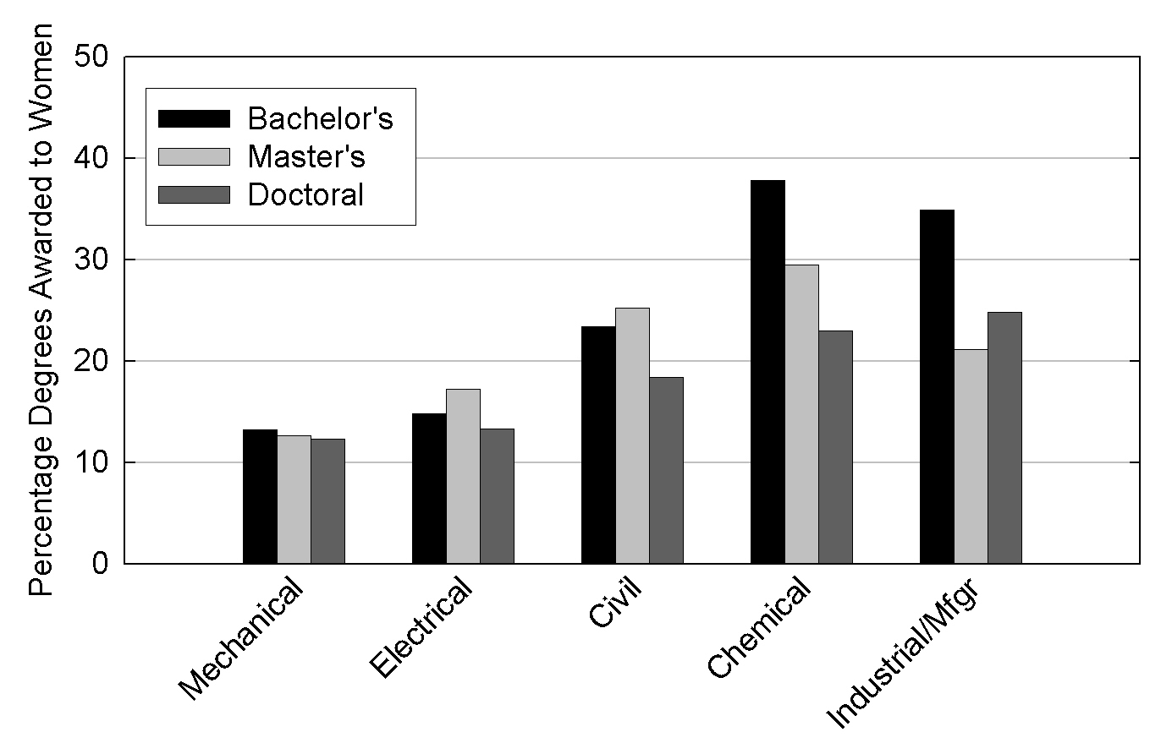
Figure 2.3: Percentage women receiving mechanical, electrical, civil, chemical, and industrial engineering degrees in 2003 ([44].

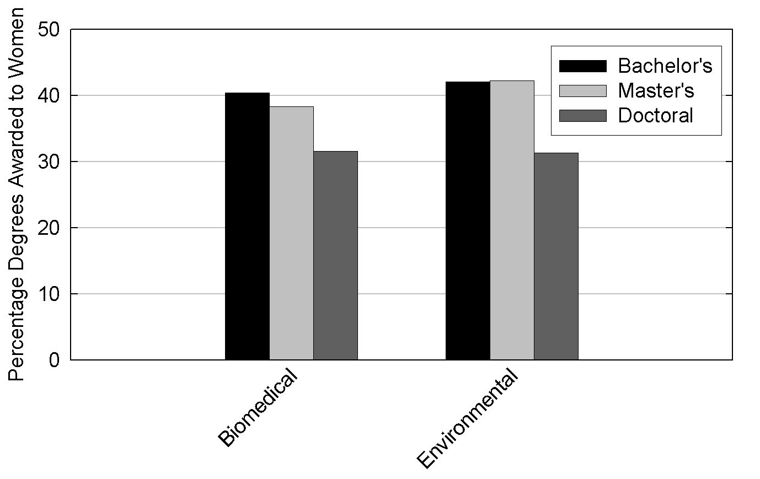
Figure 2.4: Percentage women receiving biological and environmental engineering degrees in 2003 [44].
Figure 2.5 shows the trends for three computer-related engineering disciplines, engineering computer science, computer engineering, and electrical/computer engineering. All three of these fields show a larger percentage of women obtaining master’s degrees than bachelor’s or doctoral degrees. This may be due to the declining number of males entering graduate study (see Figure 1.3), and also the influx of female foreign students and non-engineers into engineering graduate study. The data demonstrate the attractiveness of the master’s degree as a terminal degree in such fields. Women are under-represented in the computer-related graduating populations (10-20 percent) relative to their proportion in society (51 percent).

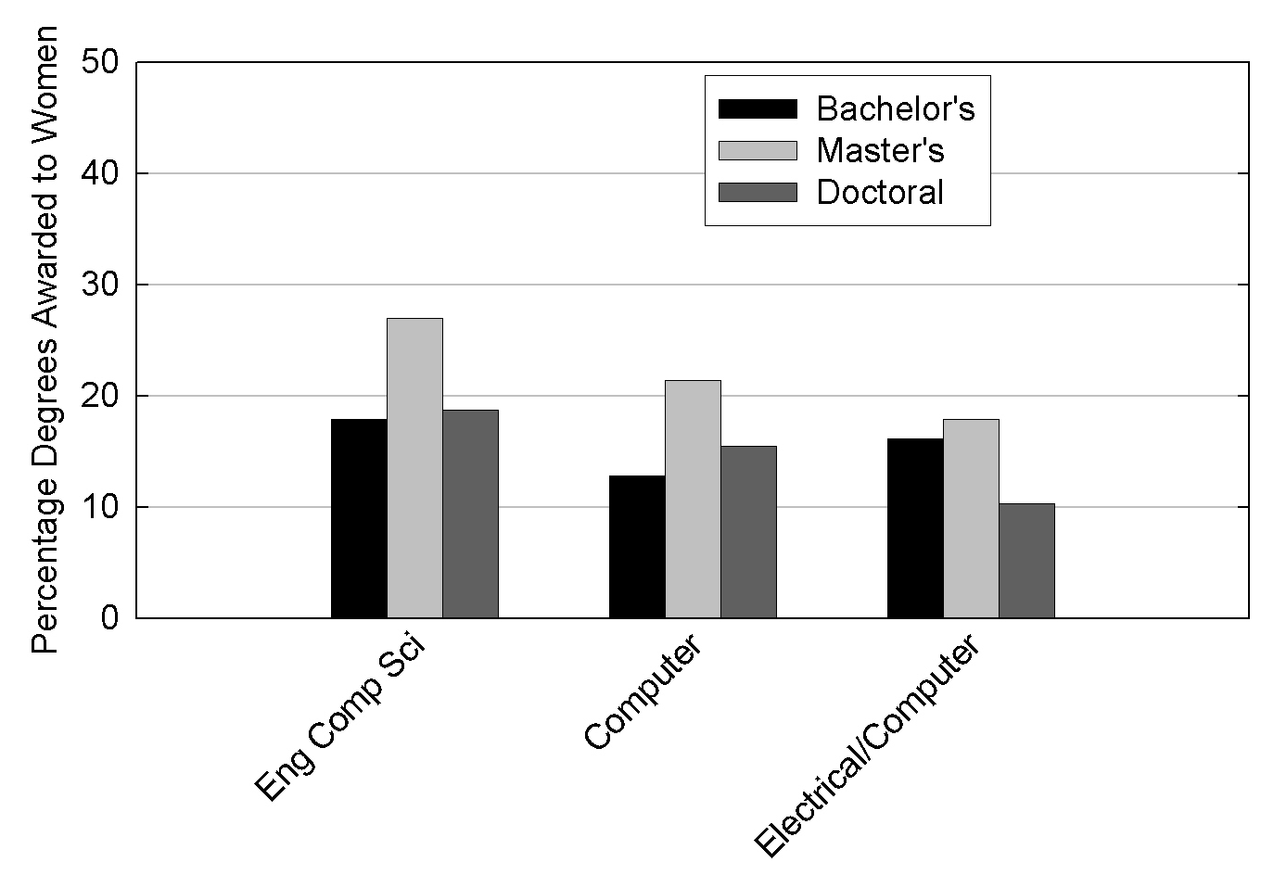
Figure 2.5: Percentage women receiving computer science, computer, and electrical/computer engineering degrees in 2003 [44].
The situation is more extreme for underrepresented minorities. Figure 2.1 shows that 5.1 percent, 4.6 percent, and 3.4 percent of engineering bachelor’s, master’s, and doctoral degrees, respectively, were awarded to African Americans in 2003. These percentages are considerably lower than the 12.2 percent of the population made up by African Americans in 2001 [9]. Hispanics earned 5.4 percent, 4.3 percent, and 3.6 percent of bachelor’s, master’s, and doctoral degrees respectively in engineering, compared to their 13 percent 2001 population percentage [9]. African Americans and Hispanics graduated in very low percentages relative to their proportions in the country. In addition, the percentages decreased when moving from bachelor’s to master’s to doctorate degrees. Thus, the minority data exhibit a “leaky pipeline” effect similar to the one shown previously for women. Research shows that women and minorities may exit the pipeline early because of lack of financial resources, lack of information about the variety of academic and research career paths, and lack of faculty mentorship and encouragement [12].
Minorities in focus groups identified several academic, social, and career issues that limit their success, a few of which are listed here [46]:
• Dealing with prejudice
• Being treated differently by faculty
• Experiencing isolation, intimidation
• Not being adequately prepared from high school
• Few social activities for minorities
• Having few role models within the alumni and industry
It was shown that minorities are helped by focusing efforts in four areas, (a) fellowships for research, (b) graduate student recruitment and retention programs, (c) “how to” seminars for graduate students, and (d) bridge programs that assist students in transition from undergraduate studies to graduate studies [47]. In addition, Reichert and Absher concluded, “it’s not so much the details of what successful [minority programs] do, rather it’s the care with which they do it.” [48]
Figure 2.6 shows the population of 20-24 year olds by race/ethnicity and shows a convergence of the white and non-white categories. This demographic fact makes participation of underrepresented groups all the more imperative to building the strength of our engineering workforce.

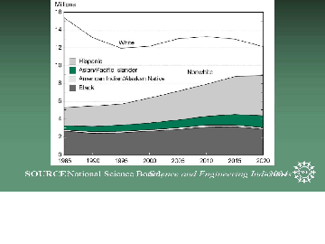
Figure 2.6: Diversity of 20 – 24 year old population [1]

2.1 Engineering Graduate Student and Faculty Diversity
Figure 2.7 compares the percentage of women earning doctorates in engineering with those working in tenured or tenure-track faculty positions in 2003. Women work in academic engineering positions in low percentages (10 percent) relative to the overall percentage of women receiving engineering doctorates (17 percent). Figure 2.8 shows that minorities also work in faculty positions in low percentages relative to the percentages obtaining doctorates. These statistics are a concern because faculty mentorship has been shown to be important to the women and minority students in the pipeline at every level. The lack of same-gender or same-ethnic-group role models may discourage students from continuing their education. [44]

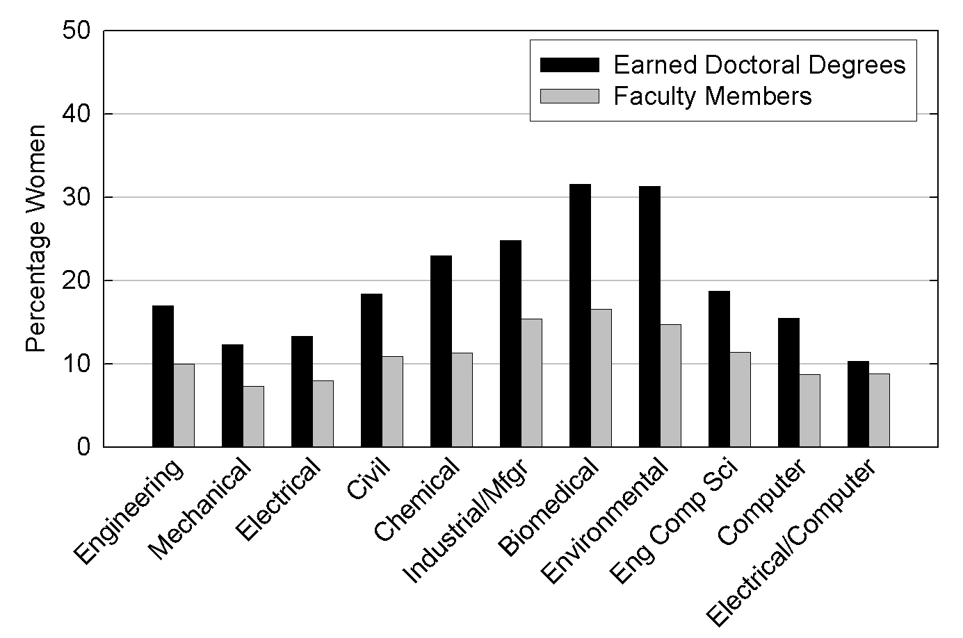
Figure 2.7: Percentage women earning doctorates and working in tenure track or tenured faculty positions in 2003 (ASEE) [44]

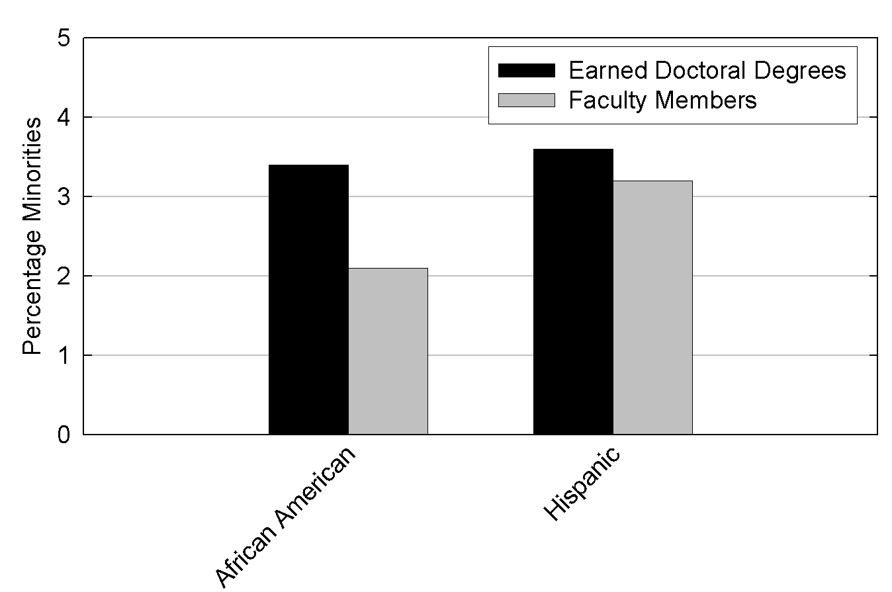
Figure 2.8: Percentage minorities earning doctorates and working in tenure track or tenured faculty positions in 2003 [44].
Figure 2.9 depicts the proportion of women in each academic rank within faculty positions. The figure shows that women make up 17 percent of assistant professors, 12 percent of associate professors, and 5.2 percent of full professors. The NSF demonstrated that women faculty earn less, are promoted less frequently to senior academic ranks, and publish less frequently than their male counterparts [49]. The NSF also found that the differences between the success of women and men in faculty careers could be related to having a family [50]. For example, women who do not have children early in their careers increase their chances for earning tenure [49]. Nelson and Rogers recently demonstrated that women are promoted through the academic ranks in lower proportion than men, not only in engineering, but also in most academic fields [51].

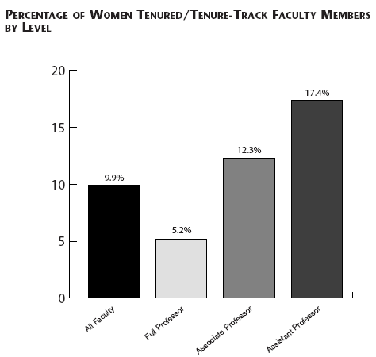
Figure 2.9: Percentage women in faculty positions at all levels in 2003 (ASEE)[44]
However, on one front, the situation is improving. Women earned doctorates and occupied assistant professorships in engineering in the same proportion (17 percent) in 2003. Unfortunately, 17 percent represents less than a third of the 51 percent proportion of women in the general population.
Figure 2.10 depicts the percentage of women and minority faculty members in 2001, 2002, and 2003. The figure shows that slight gains are being made each year, but problems with low representation persist.

Figure 2.10: Percentage women and minorities in faculty positions in 2003 (ASEE) [44]
The top five barriers faced by women in academia [53] include the difficulties associated with:
• balancing work and family responsibilities,
• time management issues in balancing teaching, research, and service,
• feelings of isolation and lack of camaraderie and mentoring,
• difficulty in gaining credibility and respect from peers and administrators, and
• the “two career” problem.
Rosser and Daniels, based on surveying NSF Professional Opportunities for Women in Research and Education (POWRE) grantees and Clare Boothe Luce Professors, found that the issue of balancing work with family responsibilities “is the most pervasive and persistent challenge facing female science and engineering faculty members, spanning the variables of time, type of institution, and discipline.” [54] They also noted that the competitiveness and inflexibility of engineering culture worsens the problem.

2.2 Interest in Engineering Education
There is substantial evidence that the interest in science and engineering among high school seniors is declining. A recent ACT Policy Report [14] using data obtained from those high school students taking the ACT found that the number of students planning on majoring in engineering has been decreasing since 1991 (Table 2.1). Annual reports by the College Board show a similar trend for those student completing the SAT I. This trend is also evident in the engineering enrollments, which have declined since the mid-80s. If you factor in that enrollments in 4-year colleges have been increasing in recent years, you find that engineering degrees as a percentage of the total number of bachelor’s degrees (Figure 2.11) has also declined.

Table 2.1: Potential engineering majors
High School Class | Number
1991 | 63,653
1992 | 66,475
1993 | 67,764
1994 | 64,571
1995 | 64,937
1996 | 63,329
1997 | 63,601
1998 | 65,329
1999 | 65,776
2000 | 61,648
2001 | 54,175
2002 | 52,112
Source: ACT Policy Report [14]

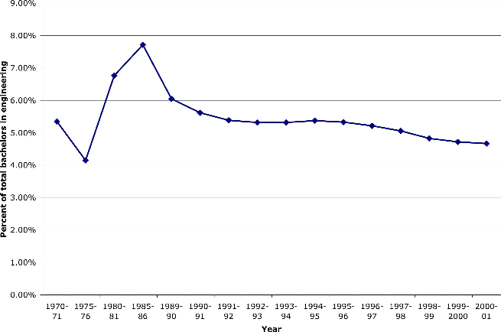
Figure 2.11: Percent of total bachelor’s degrees granted that are in engineering
Source: ACT Policy Report [14]

2.3 Interest in engineering among women and minorities
The percentage of women and underrepresented minorities enrolled in engineering education has increased in the last 25 years (Figures 2.12 & 2.13). The numbers, however, are still small, particularly when compared to their representation within the general public. Women and minorities make up more than two-thirds of the United States workforce [10], yet only represent 23 percent of engineering graduates (Figure 2.14).

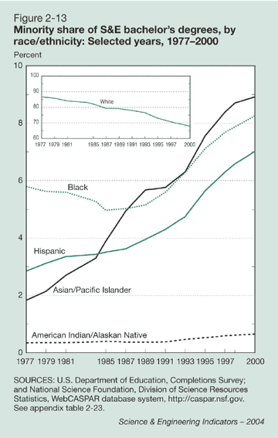
Figure 2.12: Growth in minority representation in S&E bachelor’s degrees [1]

Source: Engineering Workforce Commission
Figure 2.13: Engineering degrees by gender [2]

Figure 2.14: Engineering bachelor’s degrees in 2003 by ethnicity (AAES) [2]
In a recent paper, Johnson and Sheppard [12] did an exhaustive study of the high school class of 1990 and detailed the various stages and decision points that a high school senior would progress through from high school graduation through completion of a bachelor’s degree in engineering. There were six stages identified with a corresponding five decision points. Table 2.2 and Table 2.3 show the number and percentages of the class of 1990 high school students who completed engineering degrees, by both gender and ethnicity. There appear to be strong numbers of students entering four-year colleges, and recent data show that the number of students enrolling in four-year colleges is on the rise. However, as shown here, the number of students enrolling into engineering programs drops by an order of magnitude (just over a million to under 90,000), and with even smaller percentages of women and minorities enrolling in engineering school.

Table 2.2: Progress of students in the average high school class of 1990 through six stages, by gender and ethnicity. Numbers are thousands of students [12]

Stage | All Students | Males | Females | Whites | Asians | Blacks | Hispanics | American Indian
HS Senior Class | 3773.8 | 1894.0 | 1879.0 | 2564.2 | 169.4 | 495.4 | 513.4 | 31.4
HS Graduates | 3296.2 | 1625.0 | 1671.0 | 2382.1 | 157.4 | 430.5 | 317.3 | 27.3
College  Goers | 2156.7 | 1040.0 | 1116.3 | 1655.6 | 109.4 | 231.2 | 171.0 | 14.7
Enrollers in four-years | 1042.4 | 491.0 | 551.3 | 795.6 | 51.0 | 114.9 | 74.3 | 6.6
Enrollers in ENG Programs | 86.0 | 70.6 | 15.5 | 72.8 | 7.5 | 7.4 | 5.3 | 0.4
Engineering graduates with a bachelor’s degree | 58.9 | 49.7 | 9.2 | 46.2 | 6.3 | 2.3 | 2.8 | 0.2

Table 2.3: Percentage of students of total at first stage. [12]

Stage | All Students | Males | Females | Whites | Asians | Blacks | Hispanics | American Indian
HS Senior Class | 100 | 100 | 100 | 100 | 100 | 100 | 100 | 100
HS Graduates | 87.3 | 80.0 | 90.0 | 94.0 | 94.0 | 88.0 | 63.0 | 88.0
College  Goers | 57.10 | 54.90 | 59.39 | 65.00 | 65.00 | 47.00 | 33.00 | 47.00
Enrollers in four-years | 27.60 | 25.90 | 29.30 | 31.00 | 30.10 | 23.20 | 14.50 | 20.90
Enrollers in ENG Programs | 2.30 | 3.70 | 0.82 | 2.80 | 4.40 | 1.50 | 1.00 | 1.40
Engineering graduates with a bachelor’s degree | 1.60 | 2.60 | 0.49 | 1.80 | 3.70 | 0.50 | 0.60 | 0.60

The ACT Policy Report [14] shows a decreasing interest in engineering among women (Table 2.4). The interest among underrepresented minorities has been decreasing since reaching highs in the mid 90s (Table 2.5). It should be noted that the increase in the percentage representation for minorities is actually a result of the larger decrease in the number of Caucasian students who plan to major in engineering.

Table 2.4: Potential female engineering majors [14]

High School Class | Number | Percent
1991 | 11,710 | 18.4
1992 | 12,974 | 19.5
1993 | 13,483 | 19.9
1994 | 13,180 | 20.4
1995 | 13,389 | 20.6
1996 | 12,681 | 20
1997 | 12,803 | 20.1
1998 | 12,648 | 19.4
1999 | 12,480 | 19
2000 | 11,689 | 19
2001 | 10,073 | 18.7
2002 | 9,345 | 18

Table 2.5: Potential minority engineering majors [14]

High School Class | African American  # % | American Indian  # % | Hispanic  # %
1991 | 7,085 11.3 | 824 1.3 | 3,274 5.2
1992 | 7,659 11.6 | 863 1.3 | 3,864 5.9
1993 | 7,962 11.9 | 885 1.3 | 3,964 5.9
1994 | 7,893 12.4 | 918 1.4 | 3,881 6.1
1995 | 8,492 13.3 | 838 1.3 | 4,036 6.3
1996 | 8,021 13.3 | 870 1.4 | 3,693 6.1
1997 | 8,068 13.4 | 814 1.4 | 3,670 6.1
1998 | 8,604 13.8 | 787 1.3 | 3,653 5.9
1999 | 8,571 13.7 | 748 1.2 | 3,674 5.9
2000 | 7,977 13.5 | 645 1.1 | 3,467 5.9
2001 | 7,028 13.5 | 592 1.1 | 3,272 6.3
2002 | 6,993 14.1 | 603 1.2 | 3,440 6.9

Chapter 3

Future Issues in Engineering Workforce

3.1 Attracting a Diverse Workforce
Table 2.3 indicates that there are two points at which most students divert from a path that will lead to an engineering degree. The first is the decision to enroll in a four-year college; the second is enrollment in an engineering program, the latter showing a much greater decrease than the first. Johnson and Sheppard indicate that there are two major factors that come to play at these two decision points, the quality of the student’s preparation for college study, and the ability to pay for college. In the following, the issue of preparation is addressed.
The National Assessment of Educational Progress (NAEP), has charted student performance for the past three decades. The NAEP has developed frameworks to assess a student’s performance in mathematics and science, classified into three categories: basic, proficient, and advanced. Students in grades 4, 8, and 12 were assessed in 1996 and 2000; the results are shown in Figure 3.1. As can be seen, only a small percentage of students in 2000 reached proficiency or better in math and science (18 percent and 22 percent, respectively). Given the importance placed on performance in math and science courses in high school as an indicator of success in engineering programs, these numbers indicate that there is a small percentage of students who would appear to be prepared for engineering study.

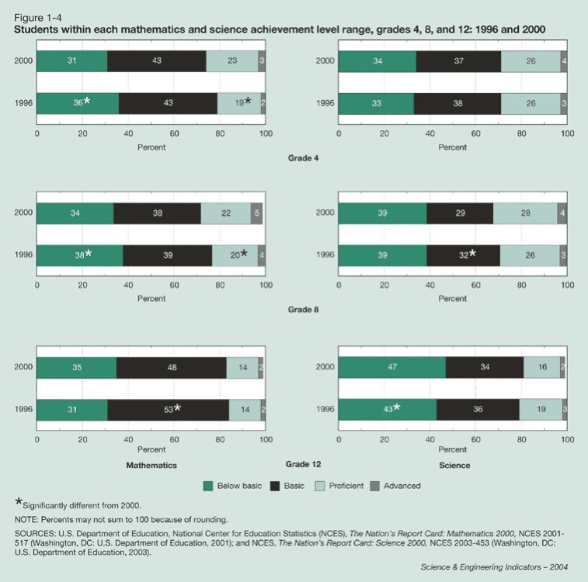
Figure 3.1: NAEP results of student achievement in mathematics and science. (Figure 1-4 from [1])
The NAEP also measures the math and science proficiency by groups. Figure 3.2 shows two interesting facts about preparation for engineering among K-12 students. First, there is a small percentage that have math and science skills at or above the proficiency required for engineering study. Second, the female percentages, while lower than males, is not significantly lower indicating that the pool of potential female students for engineering is nearly as large as the male pool.

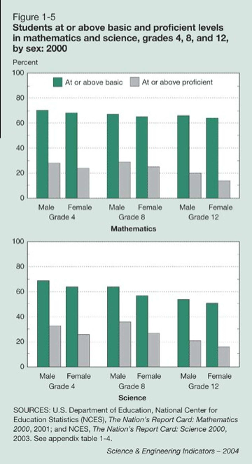
Figure 3.2: NAEP results of student achievement in mathematics and science by gender. (Figure 1-5 from [1])
Similarly, the results for proficiency for math and science by ethnicity are presented in Figure 3.3. With the exception of Asian/Pacific Islanders, higher results are again achieved by Caucasians. Well-documented research indicates that these results are the result of a number of factors related to economic status, mentoring, and quality of the teaching than to gender or race. However, they are presented here to illustrate that there are significant numbers of women and underrepresented minorities who are not being prepared for engineering study.

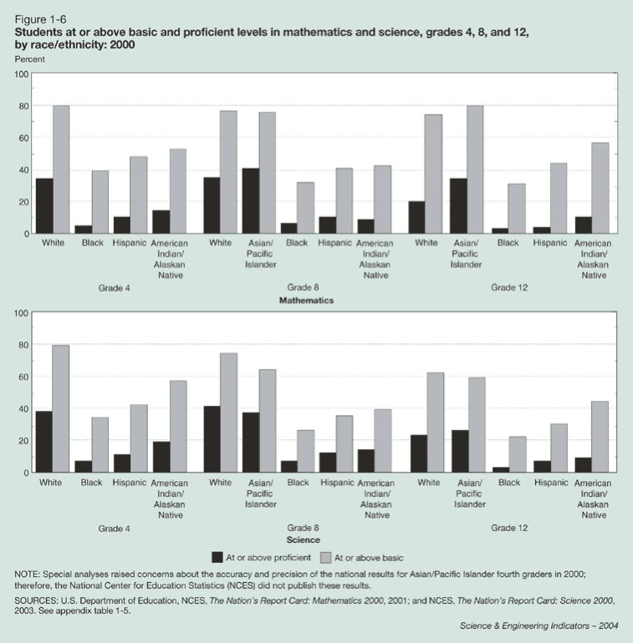
Figure 3.3: NAEP results of student achievement in mathematics and science by ethnicity. (Figure 1-6 from [1])
Beyond being prepared for engineering study, Johnson and Sheppard [12] list a number of other issues that deter women and minorities from entering or completing engineering study. For women, they indicate the following factors,
• Disillusionment with engineering and the lack of interest in the potential lifestyle,
• The culture of engineering education with its concentration on competition make them appear to be unsupportive, and
• Lack of faculty contact, role models, mentors, and peer support.
For underrepresented minority students, the ability to pay for college was a key factor in their decision to enter college. Work by National Action Council for Minorities in Engineering (NACME) to provide solid financial support for minority students has been shown to be effective in increasing the retention rate of minorities in engineering [52].
Finally, beyond the issues of preparedness, the culture of engineering education, and the affordability, there is the possibility that the curriculum itself is a barrier to underrepresented groups. This thesis is explored by Bush-Vishniac and Jarosz [11], whose long-range goal is to produce a curriculum that “retains the salient technical material but is more attractive to underrepresented groups and probably majority populations as well.” They discuss a number of features of the engineering curriculum that can either deter underrepresented groups from entering engineering or lead to reduced retention of these groups. These are summarized here.
• The lack of integration of the engineering coursework with other parts of the curriculum, and the isolation of the first two years from the final two, requires students to be very committed to the curriculum. This leads to a culture of engineering education that appears to be unattractive and uninviting.
• Nearly all engineering coursework seems to be devoid of any social relevance. Goodman et al [11], have shown that women tend to choose majors that they perceive to high levels of interaction with other people and whose benefit to society is apparent.
• The contributions to engineering by women, minorities, and other cultures, are virtually invisible in the engineering curriculum making it difficult for these groups to connect to role models in engineering from their own subculture.
• The length of the engineering curriculum is effectively 4.5 years at most schools, making issues of affordability for the economically disadvantaged groups an issue.
• The engineering curriculum is most often "sold" as a means to a job, rather than a means to a solid education. The strong professional orientation to the curriculum, often seen as a strength to some, is usually perceived as being too inflexible, which becomes a deterrent to many good students who, at 18, may feel too locked into a future that they don’t quite understand.
• The engineering curriculum is ripe with prerequisites and critical paths, particularly in specialized disciplines that may have smaller enrollments. This again can lead to financial hardships for its graduates.
• The typical engineering academic culture is more competitive than collaborative. Students seem to compete with the faculty for grades, and with their peers for class rank, mostly due to the perception that grades will determine whether or not they will get a job. Additionally, the engineering curriculum provides very little opportunity for students to engage other students outside of engineering in collaborative work, increasing the stereotype of engineers being narrowly educated.
Other issues exist, but the message is clear that the issue of diversity in engineering needs to be attacked at both ends of the “pipeline.” There is clearly a need for preparing and mentoring potential engineering students from the underrepresented groups. Also, there is a need to look at engineering education itself and reexamine many of the assumptions about engineering education that seem to be sustaining its current lack of diversity.

3.2 Preparing Students for the 21st Century
The 20th Century was transformed by engineering achievements that led to longer and better lives for people all over the world [22]. These include amazing advances in the constructed environment (e.g., affordable housing, home heating and cooling, skyscrapers, bridges and tunnels), in mobility (e.g., automobiles, trains, aircraft), in communications (e.g., telephones, television, satellites, internet), in productivity (e.g., electric power, computers, automated machines, home appliances), and health (e.g., water distribution, sanitary sewers, medical devices and imaging). During the 20th Century average life spans increased by 30 years, from 45 to 75 years; the majority of that increase came not from advances in medicine, but from the widespread availability of clean drinking water and sanitary sewers. As we begin the 21st Century there are important societal trends that effect the environment in which engineering education must take place [21]. Notable among these are the explosion of new knowledge, globalization and demographic change.
Currently knowledge is expanding at an increasing rate [[21], [32], [23], [27]]. This explosion of knowledge is occurring in all fields, but some (e.g., biology and information technologies) are experiencing what can only be termed a revolution. Some implications of this for engineering education are that students must first of all "learn to learn" so that they can acquire the knowledge needed to tackle new problems as they encounter them. Thus, there is an increasing awareness that the research-based curriculum, so successfully used in graduate studies in engineering, is a desirable approach to undergraduate engineering education as well [[19], [20]]. This accelerating growth in knowledge also suggests an emphasis on fundamentals, which are ever changing with the growth in bioengineering, information technology, nano-scale science and engineering, etc. [32]. Also, there is an increasing need for a lifelong approach to engineering education [[37], [32]]. Lifelong education in engineering addresses not only the need to acquire new knowledge after graduation, but also the fact that engineers will typically have multiple careers (not jobs, but careers! ) during their working years. An engineering education, in our increasingly technological society, provides an excellent foundation for many careers outside the traditional ones (e.g., medicine, business, management, law, education)[39]. Consequently, it is important to recognize that the true "customer" of an engineering education is the student, who will need to acquire a foundation for multiple and diverse careers, and that the "customer" is not a particular industry or company [35].
Another dominant feature of the coming century is globalization; of the top 100 economic entities in the world today, 42 are global corporations [21], [34]. One emerging aspect of this is the global competition in engineering education. The debate over whether the United States produces sufficient quantities of engineers is becoming less relevant, as an "American-style engineering curriculum" becomes a commodity available all over the world [[38], [33], [25], [23], [27]]. Many developing countries (e.g., China and India) are now educating excellent engineers, and in large quantities [[26], [44], [23], [27]]. Global companies can employ this talent at 20-40 cents on the dollar compared to developed countries (e.g., United States and Europe), whether through outsourcing of engineering jobs or importing of engineering talent [59]. Developed countries cannot compete in the arena of engineering education based upon quantity or cost. Consequently, the United States must compete on the quality (e.g., leadership, innovation) of the engineers it graduates [32]. However, the excellent engineering curricula originally developed in Europe and the United States during the past century, have indeed become a commodity and are now available to students all over the world. Consequently, to remain competitive, engineering schools in the United States must develop new engineering curricula to produce innovative leaders for an increasingly technological society.
Clearly, engineering is vital to the economy and has important benefits to society [30], [29], [33]. However, engineering education has emphasized the technology rather than its benefits to society [40]. It is now recognized that this perspective has limited the attractiveness of engineering as a career to many young people, especially women and underrepresented minorities [41], [28], [43], [40], [42]. Consequently, the engineering education enterprise in the United States has not been successful in tapping into the talents of half the population: women. In the 21st Century, the changing demographics of the United States will see significant growth in minority groups (e.g., African-Americans and Hispanic-Americans) who are also significantly underrepresented among engineers. An engineering education, which prepares students for leadership in benefiting society through innovation, will also enable a more diversified engineering workforce, one that taps into all the available talent our society has to offer. The importance of engineering concepts, not just to specialists, but to all members of society, dictates that these concepts must be more widely disseminated outside the traditional engineering curriculum (e.g., K-12 education, liberal arts education, business education) [29].
There has not been a fundamental change in engineering curricula in the United States since the shift to a more science-based engineering education in the 1960’s. However, many organizations in the United States have recognized the need for and the importance of revolutionary change in engineering education, and have begun to take steps in that direction [[18], [36], [42], [32]]. The Accreditation Board for Engineering and Technology (ABET) has developed a new approach that offers engineering schools more flexibility to update their curricula and to introduce innovations [17]. Some of the key ideas that have been piloted and tested include:
• Recognizing that the student (not industry or government) is the customer and providing the flexibility in engineering curricula to pursue a variety of careers with an engineering background.
• Expanding research-based and student-centered learning approaches in the undergraduate engineering curriculum.
• Educating engineers for leadership in an increasingly technological society by broadening engineering education and emphasizing communication, teamwork, policy, environment and ethics.
• Developing a variety of lifelong learning programs in engineering, as well as the innovative use of on-line learning tools.
• Developing various initiatives to attract underrepresented groups (i.e., women, African-Americans, Hispanic-Americans, Native-Americans) to engineering, and to attract domestic students to graduate studies in engineering.
• Emphasizing, not just technology, but the benefits engineers bring to society, throughout the engineering curriculum.
• and many others.
However, change of the magnitude that is needed in engineering curricula is difficult to achieve. Thus, the NSF has an important catalytic role, in partnership with the engineering education community, to enable the significant change in engineering education that the nation needs. Thus, the NSF Engineering Directorate’s goals for the nation in engineering education can be summarized as follows:
• Enable graduates of engineering curricula to be innovative global leaders in a rapidly changing and increasingly technological society.
• Foster an increase in the number of women and underrepresented minorities in engineering and the number of domestic students who earn doctorates in engineering.

3.3 Outsourcing, Productivity and Globalization
The movement of jobs offshore is part of a larger trend toward outsourcing traditional engineering jobs to improve efficiency and productivity in the face of global markets and competition. Unfortunately, we have no reliable numbers on outsourcing of engineering jobs. Surveys of employers by the Information Technology Association of America find that 12 percent of IT companies have moved jobs offshore and only 3 percent of non-IT firms have done so [7]. The jobs are most likely to be in the programming/software engineering category. They interpret the data to suggest that the offshore trend is expanding to include more sophisticated, value–added jobs. Of the 2.7 million jobs lost over the past three years, only 300,000 have been from outsourcing, according to Forrester Research Inc. The balance of the decrease is due to productivity gains.
In the midst of this controversy, it is clear that there is an increasing globalization of the science and engineering labor force as the location of science and engineering employment becomes more internationally dispersed and science and engineering workers become more internationally mobile. Figure 3.4 shows the most up-to-date numbers of engineering graduates being produced around the world [1]. Totaling the number of engineering graduates from China, Central/Eastern Europe, Russia and India, we approach about 500,000 engineering graduates. We know from recent visits that these numbers are increasing. According to a study by Professor Ron Hira (RIT) cited in [59] on wage requirements for engineering graduates around the world, engineers in Hungary make $25,690 per year; China, $15,120; Russia, $14,420; India, $13,580. All well below the $70,000 salary cited above in Chapter 1. Today’s communication infrastructure puts these engineers within reach of many companies, particularly those with global markets. The incentive for companies to use the engineers is both monetary (savings in wages), as well as political (investing in those markets where they want to sell their goods and services).
It is unclear at this time how the potential of this ready access will affect the market for engineering talent in this country, but it is clear that the students entering into engineering now will likely find themselves competing in a global marketplace unlike any of their predecessors. There are also strong indications that the next economic revolution will occur around a knowledge-based economy where a nation’s intellectual capital will be the measure of its ability to compete in the global marketplace. Because a knowledge-based economy doesn’t require the large investment in infrastructure and facilities that a manufacturing-based economy would require, it will be far easier for developing countries to become competitive since all it requires is human capital and a strong educational system.

Figure 3.4: Engineering degrees granted by country, 2002 [1]

Chapter 4

Conclusions and Recommendations and Actions

4.1 Conclusions
This report has reviewed the most current research available on the state and future of the engineering workforce. Given the importance of this workforce to the general well-being of the country, this has been a topic that is getting a lot of attention from various government boards and agencies. This report has attempted to provide a summary of the most currently available data, and the results of the most recent scholarly research. From this review, we draw the following conclusions:
• Enrollments in engineering programs have recovered in recent years after almost 15 years of steady decline. However, when measured against the overall increase in college enrollments, interest in engineering is still declining among all groups, but most significantly with white males, the traditional pool for engineering.
• Over the last 30 years, there has been a steady growth in the number of women and underrepresented minorities receiving engineering degrees, however, the numbers are still far behind their representation within the general public.
• Increasing the number of women and underrepresented minorities in engineering will require overcoming significant barriers currently in place in both the preparation for engineering study and the culture of engineering education.
• Gains in both number and rank among the professorate for women and underrepresented minorities have been slow, which has an impact on our ability to attract young people from these groups to engineering. If they don’t see people like themselves, with their same cultural values, then it will be difficult to see themselves pursuing an engineering degree.
• The practice of engineering is undergoing significant change, however, the engineering curriculum has been slow to respond and major rethinking and restructuring of engineering education will likely be needed in order for our engineering graduates to be competitive in a new global, knowledge based market.
• Commodity engineering (basic engineering science) can now be done anywhere and will likely be exported to those countries where engineering talent can be found at much lower costs, and there are likely to be strong political pressures to do so.

4.2 Recommendations
Our recommendations fall within the major areas of improving preparation for engineering study, changing the engineering curriculum, increasing participation in graduate study, and diversifying the engineering faculty.

4.2.1 Preparation for Engineering Study
Over the years, NSF and the Engineering Directorate have supported hundreds of precollege education interventions to seek to attract students to the engineering profession, especially women and minorities. In NSF alone, beginning with the Program for Women and Girls, started by EHR/HRD in 1993, over $90 million in awards have been made in more than 250 grants. Many projects yielded substantial results, and some did not. Given the current national strategy of "No Child Left Behind" with its emphasis on qualifications of teachers and testing of students, we recommend two outcomes for the Engineering Directorate to pursue. First, support and expand precollege teachers' understanding of the engineering profession, especially the creative, innovative aspects of it. We suggest pursuing this through expansion of the Research Experiences for Teachers program. Second, to stimulate student interest in engineering and in a way that will add to their preparedness for and ability to get into college, we suggest establishing an Advance Placement course in Engineering. Some work toward this goal is already underway. NSF involvement can accelerate the pace. The course can be built from the successful precollege projects already underway in the GK-12 projects and other successful interventions.

4.2.2 The Engineering Curriculum
Our recommendations fall within two major categories, preparing engineering students for practice in the 21st Century and broadening the participation in engineering programs. In the first, we need to look closely at the results of the Engineering 2020 report for final guidance on how the engineering curriculum should be reshaped to meet the challenges coming in this century. The results of the first phase of the work [32] highlighted several areas in need of reform. Some are being worked on in many ways (e.g. strong analytical skills, communication skills, and leadership), while others are still in need of work (e.g. developing practical ingenuity, multidisciplinary skills, creativity, and life-long learning). In light of the global competition for engineering talent that is developing, we need to address the fundamental question, “Now that the other countries know what we know about engineering education, how do we remain competitive?” Our traditional emphasis on engineering science as the most important component of the engineering curriculum is easily copied elsewhere. More importantly, it is not clear that the emphasis on engineering science produces students that understand the basic ideas and concepts of engineering in lieu of those who understand how to perform the required manipulations. There is little emphasis on critical thinking skills, dealing with multidisciplinary problems, and developing a spirit of innovation in our current engineering programs. It is interesting that, although industry seems to value these skills in it engineering staff, precious little time is spent on them. New curriculum models will need to be explored that balance an appropriate level of science and the development of “practical ingenuity”. New administrative structures may be needed to allow faculty to easily develop multidisciplinary programs that span not just across engineering departments but to the disciplines outside of engineering. A new kind of faculty may be needed that understand the innovation process in industry (examples from the business schools will likely apply here).
The second category of recommendation involves attracting a greater number of talented women and minorities to engineering. As the research has shown, there are issues of preparation and mentoring at the K-12 level that must be addressed and the recommendation above addresses this area. Here, we concentrate on recommendations for the curriculum itself. How can engineering education, its coursework, and its culture be reshaped to be more appealing to a larger, more diverse group of young people? In the past 50 years, engineering education has had a strong engineering science focus that has resulted in a culture centered on filtering out those students that cannot do the math or science. This has led to a culture that is very competitive among the students and has created a “sink-or-swim” attitude between the faculty and students. The curriculum also concentrates heavily on engineering science instead of design, and technology instead of social significance. The research shows that this culture is at odds with the value systems of most young women and minorities, and it is probably at odds with many talented students of any race and gender. Serious attempts to restructure the engineering education culture and pedagogy need to be examined and propagated.
In the end, solving this issue will likely require a large-scale effort at a university willing to take on this challenge. It will probably need a multi-agency approach, drawing support from those agencies that have a strong stake in the strength of our engineering workforce (e.g., NASA, DoD, NIH). And, to enable wide dissemination of the results, ABET will need to be a major participant.

4.2.3 Increasing Participation in Graduate Study
As noted in other areas of this report, interest in graduate study among U.S. students has been trending downward and foreign students have filled in the ranks. However, with the tightening restrictions on immigration, we will likely no longer be able to depend on this source of talent for graduate research work. We need to invest in and support programs that have been shown to be successful in encouraging our talented students to attend graduate school. Undergraduate research experiences have been shown to be such a program, and expanded support for Research Experiences for Undergraduates (REU) program should be considered. Some consideration should be given to establishing REU requirements similar to those found in the ERC program in all our major programs.
In the area of women and minority graduate students, successful student experiences in and beyond graduate school are frequently tied to mentoring relationships with faculty. Mentoring is an effective way for students to establish productive connections with professors. Without the guidance of a good mentor, the graduate student’s road to an advanced degree becomes unnecessarily anxious and difficult. We recommend (1) that we support networking of graduate students to counteract isolation and to actively promote persistence and (2) that we develop exemplary models of training faculty to improve mentoring and advising skills.

4.2.4 Diversifying the Engineering Faculty
Increasing the presence of women and minority faculty in engineering schools is critical since increasing the role models and mentors encourages the persistence of undergraduate and graduate students in technical fields. In the area of faculty programs, we recommend several items. First, support networks for women and minority faculty should be built, drawing upon the highly successful minority workshops sponsored by selected ENG divisions in recent years. Another recommendation is to develop networks of CAREER awardees to encourage them to learn from their collective experiences, especially the education integration aspects of their CAREER grants. A third recommendation is to encourage the formation of faculty re-entry programs for women and minority. These would attract experienced women and minority engineers from industry and national laboratories to careers in academia through programs that support doctoral study through start up packages. Having faculty with industry and national laboratory experience would be very helpful for achieving Vision 2020 goals.
An additional suggestion is for ENG to implement the results of ADVANCE and similar institutional transformation programs. Significant experiments are underway to transform institutions to foster success of faculty and students, especially those from underrepresented groups, and ENG should capitalize on these NSF investments. The findings of such institutional transformation work should be broadcast and implemented on a wider scale. Challenging issues such as the need for dual-career couple employment, the misalignment of the biological clock and the tenure clock, and the isolation felt by individuals who are different from the majority need more innovative solutions. Attention should be paid to the vast social sciences literature before solutions are formulated. Incorporation of leadership and management training, perhaps in the form of using professional leadership coaches, should be pursued for engineering professors as well as academic administrators such as presidents, engineering deans, and engineering department chairs.

4.3 Actions

Flowing from these recommendations, the task group suggests the following actions. These include estimates of additional financial resources for each.

4.3.1 Actions for Preparing for Engineering Study

A. Expand Research Experiences for Teachers

Fund more teachers in sites and supplements.

Network teachers to support each other.

Network PIs of sites to share experiences.

Identify and broadcast best practices.

Assess and evaluate.

New dollars = $1.6M in FY 06 with continued growth to $10 M across the next five years.

B. Establish an Advanced Placement Course in Engineering

Join discussions underway at Johns Hopkins University/National Academy of Engineering SEEK-16 Summit on Feb 21-22, 2005.

Support planning activities for establishing an AP course.

Fund development of the course materials and pedagogy.

Support teacher training for the AP course.

New dollars = $0.3M in FY 05 with continued growth for the next five years. Share cost with NSF Directorate for Education and Human Resources.

4.3.2. Actions for the Engineering Curriculum

A. Sponsor Engineering Education Research

Support Gordon-style conferences to explore issues in engineering education research.

Identify most important and opportune topics.

Set research agenda.

Fund research activity.

Assess progress and opportunities.

New dollars = $1.0M in FY 05 with growth to $25M in ten years. Co-fund with NSF Directorates for Education and Human Resources and Social, Behavioral and Economic Sciences.

B. Restructure Engineering Education Culture and Pedagogy

Offer comprehensive grants to Engineering Schools to implement research results, the NAE “Vision 2020” report, the NAE “Assessing the Capacity of the U.S. Engineering Research Enterprise” report, and the Council of Competitiveness “Innovation” report.

New dollars = $0.250 M in FY 2005 then grow to $15M over the next five years. Co-fund with the NSF Directorate for Education and Human Resources, private foundations and industry.

4.3.3. Actions for Increasing Participation in Graduate Study

A. Expand Research Experiences for Undergraduates

Support 1500 more REU students per year and explore other REU funding mechanisms.

Offer one year graduate fellowships to students who participate in NSF REU and go for PhD in engineering.

Encourage engineering schools to recruit more US PhD students and retain them.

New dollars = $7.5M for REU and $10 M for fellowships.

B. Sponsor Research on Graduate Education in Engineering

Draw attention to the need for research on graduate education.

Identify most important and opportune topics.

Set research agenda.

Fund research activity.

Assess progress and opportunities.

New dollars = $2M per year for five years

C. Improve Support Networks and Mentoring for Graduate Students

Hold workshop to summarize research on best practices in networking and mentoring.

Broadcast these results widely and provide technical assistance to schools that want to provide these services.

Continue to research and use these results to improve.

New dollars = $1M per year for five years

D. Train Faculty in Mentoring and Advising Graduate Students

Hold workshop to summarize research on best practices in mentoring and advising.

Require exemplary mentoring and advising on all NSF grants.

Continue to research and use these results to improve.

New dollars = $1M per year for five years

4.3.4 Actions to Diversify the Engineering Faculty

A. Improve Support Networks for Women and Minority Faculty

Continue and expand the division sponsored meetings of women and minority faculty.

Provide continuing networking infrastructure for the participants.

Assess these activities.

Continue research on networking and use these results to improve.

New dollars = $1M per year for five years

B. Network CAREER Faculty

Sponsor regular meetings of CAREER faculty where they share results on integrating research and education.

Provide continuing networking infrastructure for the participants.

Broadcast the best practices widely.

Assess these activities.

New dollars = $1 M per year

C. Establish Re-entry Programs to Bring Practicing Engineers to Academe

Hold workshop to summarize research on re-entry programs.

Broadcast these results widely.

Provide planning grants for schools to initiate programs.

Support students with stipends, and startup packages if they become faculty.

New dollars = $ 6 M per year for five years

D. Implement Results of Institutional Transformation Programs

Communicate best practices results of ADVANCE to the engineering community.

Develop NSF funding opportunities based on ADVANCE results.

New dollars = $1M per year for five years

E. Provide Leadership Training for Faculty and Administrators

Co-sponsor the NAE/INTEL workshop on best practices for developing academic leadership.

Offer a pilot course in summer of 2005.

Continue to research and use these results to improve and scale up.

New dollars = $0.1 m in FY 05 the $1M per year for five years. Co-fund with industry.

Bibliography
[1] National Science Board, Science and Engineering Indicators 2004, Volume 1, National Science Foundation, Arlington, VA, 2004.
[2] Engineering Degrees 2003, Engineering Workforce Commission, Association of American Engineering Societies, 2003 www.aaes.org/ewc.
[3] Bureau of Labor Statistics, Data from “Employment by occupation, 2002 and Projected 2012”, US Department of Labor, www.bls.gov/emp/emptab21.html and Data from Howard Hagee of the
Division of Labor Force.
[4] “2004 –2005 Grads See Modest Rise in Salary Offers”. February 8, 2005. National Association of Colleges and Employers. www.naceweb.org.
[5] “Salaries of Scientists, Engineers and Technicians: A Summary of Salary Surveys”, 20th Edition, July 2003 by Eleanor L. Babco and Nathan E. Bell of the Commission on Professionals in Science and Technology, www.cpst.org.
[6] ASEE Profiles “2003 Profiles of Engineering and Engineering Technology Colleges”, American Society of Engineering Education, 2003.
[7] “On the Offshoring of High Skilled Jobs”, Ronil Hira, Testimony to the Committee on Small Business of the U.S. House of Representatives, 20 October 2003. www.ieeeusa.org/forum/POLICY.
[8] “Critical Path Analysis of California” Science and Technology Education System. A Report Prepared by the California Science and Technology Council. April 2002. www.ccst.ucr.edu.
[9] National Science Foundation, Division of Science Resources Statistics, Women, Minorities, and Persons with Disabilities in Science and Engineering: 2004, NSF 04-317 (Arlington, VA, 2004; updated May 2004). Available from http://www.nsf.gov/sbe/srs/wmpd.
[10] Congressional Commission on the Advancement of Women and Minorities in Science, Engineering and Technology Development, Land of Plenty: Diversity as America’s Competitive Edge in Science, Engineering and Technology, September 2000.
[11] Busch-Vishniac, I. J. and Jarosz, J. P., “Can Diversity in the Undergraduate Engineering Population Be Enhanced Through Curricular Change? ", Journal of Women and Minorities in Science and Engineering, vol. 10, pp. 255-281, 2004.
[12] Johnson, M. J., and Sheppard, S. D., “Relationships Between Engineering Student and Faculty Development Demographics and Stakeholders Working to Affect Change", Journal of Engineering Education, vol. 93, no. 2, pp. 139-151, 2004.
[13] Campbell, P. B., et al., Upping the Numbers: Using Research-Based Decision Making to Increase Diversity in the Quantitative Disciplines, GE Fund Report, January, 2002.
[14] Noeth, R. J., Cruce, T., and Harmston, M. T., Maintaining a Strong Engineering Workforce, ACT Policy Report, 2003.
[15] American Association for the Advancement of Science, In Pursuit of a Diverse Science, Technology, Engineering and Mathematics Workforce: Recommended Research Priorities to Enhance Participation by Underrepresented Minorities, NSF Grant Number HRD-9817536, A002, December, 2001.
[16] Adelman, C., Women and Men on the Engineering Path: A Model for Analyses of Undergraduate Careers, Department of Education and the National Science Foundation, May, 1998.
[17] Accreditation Board for Engineering and Technology (ABET), Sustaining the Change, www.abet.org.
[18] American Society of Civil Engineers (ASCE), Civil Engineering Body of Knowledge for the 21st Century, www.asce.org.
[19] Carnegie Foundation’s Boyer Commission (CFBC), Reinventing Undergraduate Education, 1998.
[20] Carnegie Foundation’s Boyer Commission (CFBC), Reinventing Undergraduate Education: Three Years After the Boyer Report, 2001.
[21] Center for Strategic and International Studies (CSIS), The Seven revolutions, www.7revs.org .
[22] Constable, G. and B. Somerville, A Century of Innovation: Twenty Engineering Achievements That Transformed Our Lives, National Academy of Engineering, 2003.
[23] Duderstadt, J.J., Presentation to the NSF Engineering Advisory Committee, May 2004.
[24] Gibbons, Michael T., Engineering on the Rise, ASEE, www.asee.org.
[25] Harvard University Science and Engineering Workforce Project (HUSEWP), see http://www.nber.org/ sewp/.
[26] Ko, Tsun, Engineering Education for Developing China in the Twenty-First Century, National Academy of Engineering (NAE), Approaches to Improve Engineering Design, 2002a.
[27] National Academy of Engineering (NAE), Assessing the Capacity of the U.S. Engineering Research Enterprise to Meet The Future Needs of the Nation, 2005 (in press).
[28] National Academy of Engineering (NAE), Diversity in Engineering: Managing The Workforce of the Future, 2002b.
[29] National Academy of Engineering (NAE), Impact of Academic Research on Industrial Performance, 2003.
[30] National Academy of Engineering (NAE), Raising Public Awareness of Engineering, 2002.
[31] National Academy of Engineering (NAE), Technically Speaking: Why All Americans Need to Know More About Technology, 2002.
[32] National Academy of Engineering (NAE), The Engineer of 2020: Visions of Engineering in the New Century, 2004.
[33] National Science Board (NSB), The Science and Engineering Workforce: Realizing America’s Potential, National Science Foundation, August 14, 2003.
[34] Drucker, P., “Peter Drucker Sets Us Straigh”, Fortune Magazine, January 12, 2004.
[35] Seely, Bruce E., The Other Re-engineering of Engineering Education, Journal of Engineering Education, July 1999.
[36] Shuman, Larry J., et al, The Future of Engineering Education, ASEE/IEEE Frontiers in Engineering Education Conference, November 2002, Boston, MA.
[37] Smerdon, E.T., “Lifelong Learning for Engineers: Riding The Whirlwind”, National Academy of Engineering, The Bridge, Vol. 26, No., Spring/Summer 1996.
[38] Teitelbaum, M. S., “The U.S. Science and Engineering Workforce: An Unconventional Portrait”, GUIRR Summit, November 12, 2002.
[39] Tryggvason, G., Thouless, M., Dutta, D., Ceccio, S. and Tilbury, D.M., “The New Mechanical Engineering Curriculum at the University of Michigan”, Journal of Engineering Education, July 2001, pp 437-444.
[40] Williams, R., “Education for the Profession Formerly Known as Engineering”, Chronicle of Higher Education, 1/24/2003.
[41] WMEP, Women and Men of the Engineering Path.
[42] Wormley, D., “Engineering Education and the Science and Engineering Workforce”, NAE Pan-Organizational Summit on the U.S. Science and Engineering Workforce, 2003.
[43] Wulf, W.A., and George M.C. Fisher, “A Makeover for Engineering Education”, Issues in Science and technology On-Line, Spring 2002.
[44] Gibbons, Michael T., “A new look at Engineering." American Society for Engineering Education, 2003. Available from http://www.asee.org/about/publications/profiles/upload/2003engprofile.pdf .
[45] National Science Foundation, Division of Science Resources Statistics, Science and Engineering Degrees: 1966-2001, NSF 04-311, Project Officers, Susan T. Hill and Jean M. Johnson. Available from http://www.nsf.gov/sbe/srs/nsf04311/htmstart.htm.
[46] Van Aken, E.M., Watford, B., and Medina-Borja, A., The Use of Focus Groups for Minority Engineering Program Assessment, Journal of Engineering Education, July 1999, p. 333.
[47] Reichert, M., and Absher, M., “Graduate Engineering Education of Underrepresented Populations”, Journal of Engineering Education, July 1998, p. 257.
[48] Reichert, M., and Absher, M., Taking Another Look at Educating African American Engineers: The Importance of Undergraduate Retention, Journal of Engineering Education, July 1997, p. 241.
[49] National Science Foundation, Division of Science Resources Statistics, Gender Differences in the Careers of Academic Scientists and Engineers: A Literature Review, NSF 03-322, Project Director, Alan I. Rapoport. Available from http://www.nsf.gov/sbe/srs/nsf03322/start.htm.
[50] National Science Foundation, Division of Science Resources Statistics, Gender Differences in the Careers of Academic Scientists and Engineers, NSF 04-323, Project Officer, Alan I. Rapoport. Available from http://www.nsf.gov/sbe/srs/nsf04323/start.htm.
[51] Nelson, D.J. and Rogers, D.C., “A National Analysis of Diversity in Science and Engineering Faculties at Research Universities”, 2004. http://cheminfo.chem.ou.edu/Edjn/diversity/briefings/Diversity Report Final.pdf .
[52] Campbell, G., "Keeping What We’ve Got: Effective Strategies for Retaining Minority Freshmen in Engineering," NACME Research Letter, National Action Council for Minorities in Engineering (NACME), New York, Vol. 9, No. 1, 1999.
[53] Rosser, S.V., and Lane, E.O., “Key Barriers for Academic Institutions Seeking to Retain Female Scientists and Engineers: Family-Unfriendly Policies, Low Numbers, Stereotypes, and Harassment”. Journal of Women and Minorities in Science and Engineering, Vol. 8, pp. 161-189, 2002.
[54] Rosser, S.V., and Daniels, J.Z., “Widening the Paths to Success, Improving the Environment, and Moving Toward Lessons Learned from the Experiences of Powre and CBL Awardees”, Journal of Women and Minorities in Science and Engineering 10:131, 2004.
[55] “Engineering Education and the Science and Engineering Workforce.” David Wormly. Pan Organization Summit on the U.S. Science and Engineering Workforce: Meeting Summary. www.nap.edu/openbook National Academy of Sciences. 2003.
[56] “Reinventing Undergraduate Education: A Blueprint for America’s Research Universities, The Boyer Commission on Educating Undergraduates at the Research University. 1998.
[57] “The Science and Engineering Workforce: Realizing America’s Potential”, National Science Board, August 2003.
[58] “Women and Men of the Engineering Path: A Model for Analyses of Undergraduate Careers. “U.S. Department of Education and the National Institute for Science Education. May 1998.
[59] McGraw, D, “My Job Lies Over the Ocean", Prism Magazine, Volume 13, Number 4, December 2003.
[60] “New Formulas for America’s Workforce: Girls in Science and Engineering", NSF Publication 03-207.

