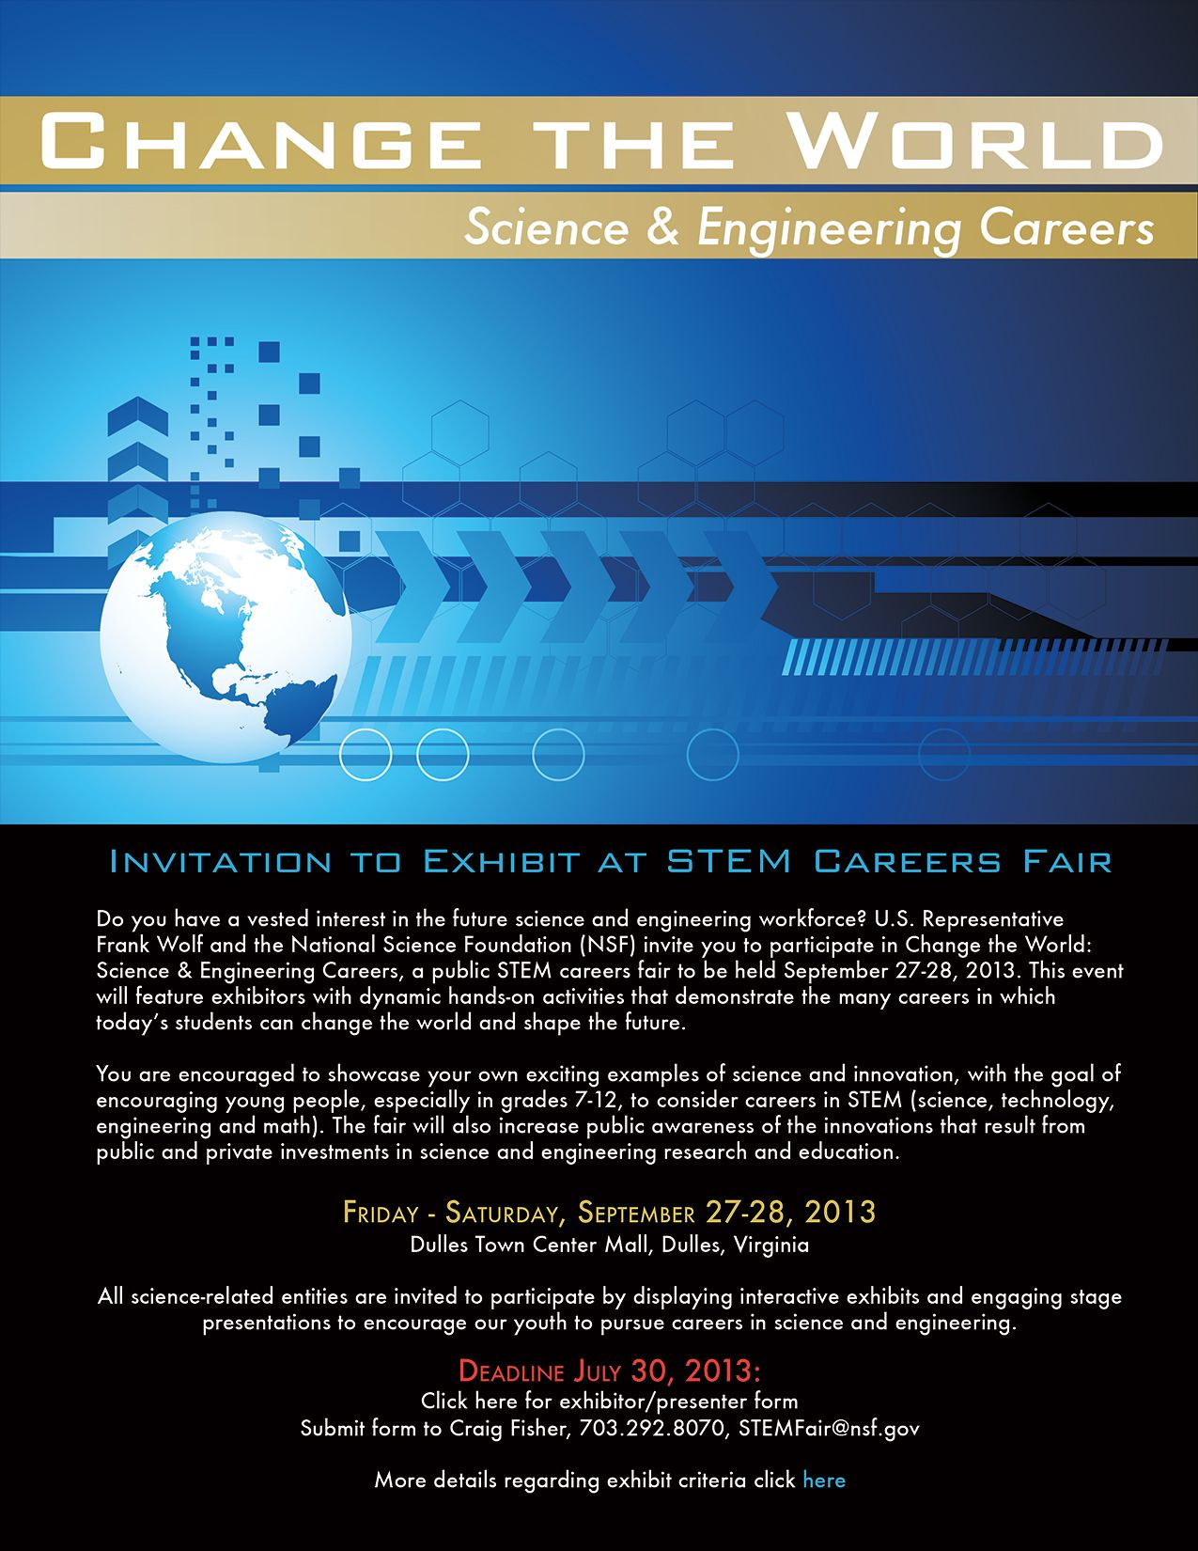
CENTER STAGE PERFORMANCES
FRIDAY, SEPTEMBER 27th
12:00 pm - 6:00 pm, PERFORMANCES EVERY HALF HOUR

Give Me an S . . T . . E . . and M! Science Cheerleaders
The Science of Storytelling Story Pirates
Up Close and Personal with Tornadoes Storm Chasers Josh Wurman and Karen Kosiba
Rover 911! Pet CPR Great Falls Animal Hospital
Dinosaurs Alive Dave Clark, Producer
Birds of Prey Potomac Overlook Park
The Science of Cooking Cookology Chefs
Magical Metal Leon White, Engineer

CENTER STAGE PERFORMANCES
SATURDAY, SEPTEMBER 28th
11:00 pm - 4:00 pm, PERFORMANCES EVERY HALF HOUR

Give Me an S . . T . . E . . and M! Science Cheerleaders
The Science of Storytelling Story Pirates
Up Close and Personal with Tornadoes Storm Chasers Josh Wurman and Karen Kosiba
Rover 911! Pet CPR Great Falls Animal Hospital
Birds of Prey Potomac Overlook Park
The Science of Cooking Cookology Chefs
Magical Metal Leon White, Engineer

