 NSF Day Evaluation 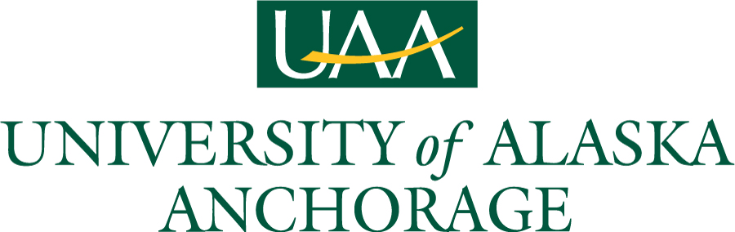

Please answer the following questions by marking the scale according to your experience with this workshop:

1. What position best describes you:

(a) Faculty: Tenured (e) Post Doc
(b) Faculty : Tenure-track (f) Student
(c) Faculty: Non-tenured track (g) Other, please specify: _____________________________
(d) Administrator

2. Have you ever applied for NSF funding?

(a) No (b) Yes

3. If you answered yes to having applied for NSF Funding, please answer the following:

(a) I applied _____ times and was successful _____ times (b) I currently have ______ (many) proposals under consideration.

3. Please describe your knowledge of NSF grant processes before and after the workshop:

Before: Excellent Good Fair Poor
After: Excellent Good Fair Poor

4. The duration of the workshop was:

(a) Too Short (b) Just Right (c) Too Long (d) No Opinion

5. Networking time with colleagues was:

(a) Too Short (b) Just Right (c) Too Long (d) No Opinion

6. The number of presentations was:

(a) Too Few (b) Just Right (c) Too Many (d) No Opinion

7. How would you rate the organization of the workshop?

(a) Excellent (b) Good (c) Fair (d) Poor

8. The overall workshop:

(a) Exceeded my expectation s (c) Almost met my expectations
(b) Met my expectations (d) Failed to meet my expectations

9. If you answered either (c) or (d) to question 8, what could NSF do to help meet your expectations?

__________________________________________________________________________________________________

10. Based on this experience, would you recommend this workshop to a colleague?

(a) Yes (b) No (c) Maybe

11. How did you hear about this NSF Day?

(a) NSF website/listserv (e) Social media
(b) My institution (f) NSF Program Manager
(c) Word of mouth (g) Other, please specify: ___________________________
(d) Professional network

12. Which breakout session(s) did you attend?

(a) Computer and Information Science and Engineering (e) Biological Sciences
(b) Education and Human Resource (f) Mathematical and Physical Sciences
(c) Engineering (g) International Science and Engineering
(d) Geosciences (h) Social Behavioral and Economic Sciences

13. What aspect of the breakout session(s) did you find most valuable? Are there ways we could improve the experience?

14. Are there additional topics you would like for us to address during the course of the day?

__________________________________________________________________________________________________

15. What was the workshop highlight for you?

__________________________________________________________________________________________________

16. Do you see ways that the workshop could be improved? If yes, please let us know how we can improve:

__________________________________________________________________________________________________

